
Friday 15th January 2021

Good morning Lime Class!

We have made it to the end of our second week of remote teaching and learning! I hope you all have a rest this weekend.

I am looking forward to seeing you all again later on this morning (11.30) for our Friday Zoom session. If you have any work or show and tell that you would like to share, please have it ready with you ready to show.

Please find your learning for today below.
If you have any issues, please do let me know as I am very happy to help in any way I can.
Please stay in close contact and email your learning each day to limeteacher@west-malling.kent.sch.uk
Maths
This week we are going to be looking at numbers to 20.
Today we are moving on to one more and one less.

Watch this video: https://player.vimeo.com/video/480325729 (Don’t worry about doing the worksheet part)

The video will start by using pictures to help you to work out 1 more and 1 less than a number. Then you will be asked to find 2 ways to describe a number using more than and less than sentences, for example, 15 is one more than 14 and 15 is one less than 16. You may want to draw a number line/track to help you.
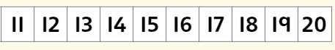

Now complete the Mathletics activities on more, less or the same to 20.

Today I have added 2 optional sheets which can be printed if you want to. You will use ten frames and number lines to show me 1 more and 1 less than a number. Use the number track above to help you work out the number sentences just like you did on the video.
Reading
Read for AT LEAST 10 minutes every day.

I know you can do it as we would normally do a lot more when we are at school.
I would love you all to use BugClub everyday as the Bug questions teach important reading skills that we would normally be covering in lessons. Every day, I will check to see who has read and how you have got on with the questions.
If you would prefer not to use a screen to read all of the time, it is absolutely fine to read books you have at home.
Reading every day is the most important thing to do.
Phonics and Tricky ‘red’ Words
Each day, I will be giving you a sound to practice or recap. It will have the rhyme that we use to help us to learn it and some real words that contain the special friend. Have a go at reading the words and writing them making sure you use your ‘Fred Fingers’ to help you. There will also be some nonsense words to go with each sound for you to practice reading.
This week’s ‘red’ words:
said
was
no
so
go
old
her

Each week, there will be 7 ‘red’ words for you to learn how to read and spell. 2 of these will be words we have looked at before and 5 will be new ones. Have a go at reading them and writing them, either as a list or in a sentence – “Go to bed” said Mum. How old are you? Remember capital letters, finger spaces and full stops/question marks!
English
Today we will be carrying on with the story of Jack and the Beanstalk.

Before you watch the video: Do you think the Giant’s wife is a good or bad character? Why do you think this? What about Jack’s Ma? Listen out for what these characters say and do in this episode.

As you are watching the video:
Listen and look out for how the Giant’s wife and Jack help each other.
Listen and look out for what the Giant says and does.

Watch this video: 10: ‘The bag of silver coins’ - https://www.bbc.co.uk/teach/school-radio/english-ks1-jack-and-the-beanstalk-episode-10/z4wynrd

After you have watched the video, have a go at answering these questions: (Tell your answers to an adult)
Where is Jack while the Giant is eating his supper?
What does the Giant eat for supper?
Why does the Giant ask for his bag? What is inside?
How does Jack manage to get the bag from the Giant?
What does Jack offer to do?
What does Jack’s Ma say when he gets back?

Activity: Describing words.
Can you retell what happens in this episode? Can you recall any of the words that are used to describe things in this episode (adjectives)? For example, the glinting silver coins. Have a go at completing the sentences on the sheet below using the words in the box to help you.
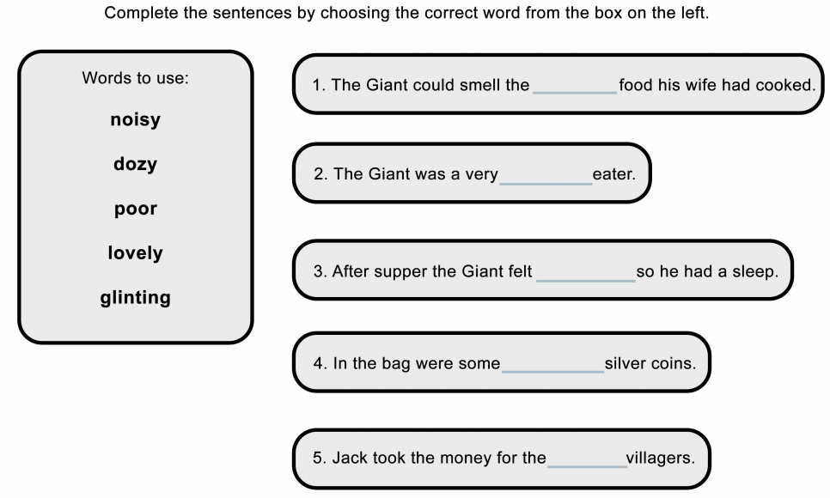
I hope you have another fantastic day of learning. Do email me if there is anything I can help you with or if you have any questions. I look forward to seeing you on Zoom later, where we will be having a shape scavenger hunt, and receiving some more of your amazing learning throughout the day. Have a lovely weekend.

