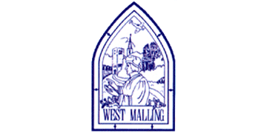
Monday 18th January 2021

Good morning Lime Class!
I hope you have all had a nice weekend and are ready for another week of amazing learning.

I am looking forward to our ZOOM session tomorrow at 11.30 where we can have a quick catch up and continue with our Science learning. Try to have any work you have done nearby so that we can share each other’s learning. But most importantly I want to see you!

Please find your learning for today below.

If you have any issues, please do let me know as I am very happy to help in any way I can.
Please stay in close contact and email your learning each day to limeteacher@west-malling.kent.sch.uk
I would also love to hear about any other news or show and tell you have to share. So please send me an email and let me know if you would like your news shared with your friends on the class webpage.
Maths
This week we are continuing to look at numbers to 20.
Today we are comparing numbers of objects.

Watch this video: https://player.vimeo.com/video/483168827 (Don’t worry about doing the worksheet part)

The video will ask you to compare 2 different objects for example candles on a cake and muffins in a tray. How do you compare groups of objects? What can you do to check? Next you will be using the language greater than, less than and equal to. Use your knowledge of tens and ones from last week to help you. You can use objects and do it practically if you want too.

Now complete the mathletics tasks I have set you on comparing numbers to 20.

I have added some optional sheets for you to have a go at today. There is no need to print them out. Questions 1 and 2 ask you to show who has fewer and questions 3 and 4 ask you to show who has more. You will need to use the greater than > and less than < signs to help fill in the number sentences. Remember the crocodile eats the biggest number! I have added a challenge question of some of you to try!
Reading
Read for AT LEAST 10 minutes every day.

I know you can do it as we would normally do a lot more when we are at school.
I would love you all to use BugClub everyday as the Bug questions teach important reading skills that we would normally be covering in lessons. Every day, I will check to see who has read and how you have got on with the questions.
If you would prefer not to use a screen to read all of the time, it is absolutely fine to read books you have at home.
Reading every day is the most important thing to do.

Phonics and Tricky ‘red’ Words
This week’s ‘red’ words:
are
want
do
many
any
one
anyone
Each day, I will be giving you a sound to practice or recap. It will have the rhyme that we use to help us to learn it and some real words that contain the special friend. Have a go at reading the words and writing them making sure you use your ‘Fred Fingers’ to help you. There will also be some nonsense words to go with each sound for you to practice reading.
Each week, there will be 7 ‘red’ words for you to learn how to read and spell. 2 of these will be words we have looked at before and 5 will be new ones. Have a go at reading them and writing them, either as a list or in a sentence – Are you a boy? Do you want any sweets? Remember capital letters, finger spaces and full stops/question marks!
English
This week we will be continuing with our work on the Story of Jack and the Beanstalk. I have been so impressed with the work you have done on this already and can see that you are really understanding the story.

Before you watch the video: Do you think that Jack and his Ma will be happy now? Why do you think this? Can you make a prediction (have a guess) based on the story so far?

As you are watching the video:
Listen and look out for how Jack’s life changes
Listen and look out for how the Giant’s wife helps him again.

Watch this video: 11: ‘Th magic hen.’ - https://www.bbc.co.uk/teach/class-clips-video/english-ks1-jack-and-the-beanstalk-pt11/zfhc7nb

After you have watched the video, have a go at answering these questions: (Tell your answers to an adult)
How does Jack’s life change after he gets down from the beanstalk?
Why does Jack go back up the beanstalk?
Where does the Giant’s wife hide Jack this time?
What does the Giant ask his wife to bring him this time?
What is special about the hen?

Activity: Retell the episode.
Recall what happened in this episode. Complete the sheet below by matching the picture to the sentence.
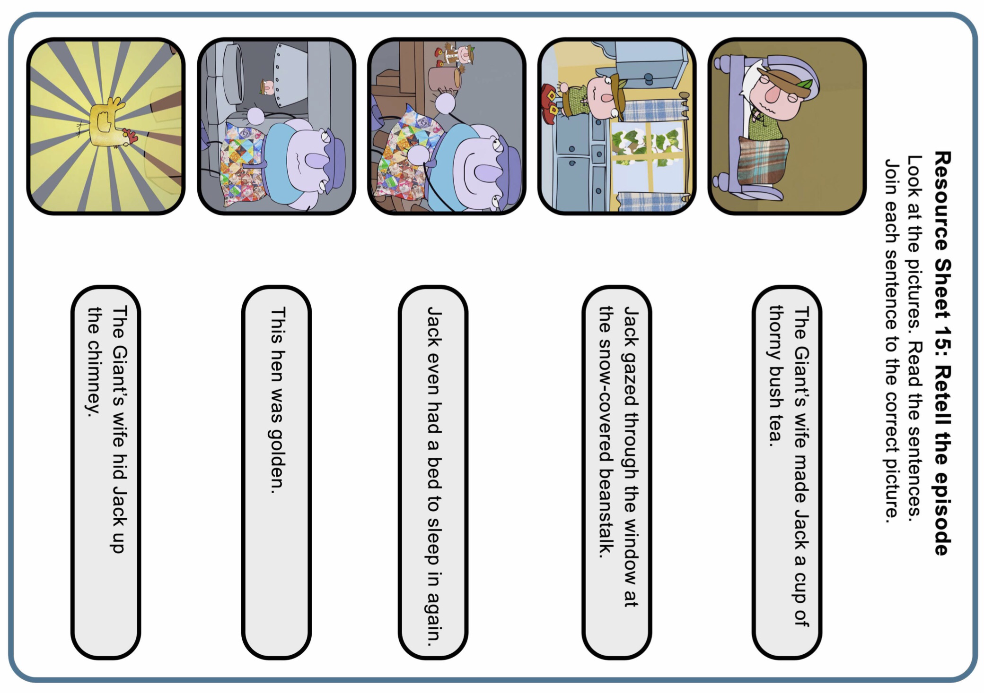

I hope you have a fantastic day of learning. Remember, we will have a zoom session tomorrow at 11.30am. Do email me if there is anything I can help you with or if you have any questions.

