
Tuesday 19th January 2021

Good morning Lime Class!

I am really looking forward to our get together over ZOOM for a catch up and a quick science lesson today at 11.30am. Try to have any work you have done nearby so that we can share each other’s learning. But most importantly I want to see you! I have something exciting to tell you about our Zoom session on Friday!
Please find your learning for today below.
If you have any issues, please do let me know as I am very happy to help in any way I can.
Please stay in close contact and email your learning each day to limeteacher@west-malling.kent.sch.uk
I would also love to hear about any other news or show and tell you have to share. So please send me an email today and let me know if you would like your news shared with your friends on the class webpage.
Maths
This week we are continuing to look at numbers to 20.
Today we are comparing numbers.

Watch this video: https://player.vimeo.com/video/483169674 (Don’t worry about doing the worksheet part)

In this video you will be looking at the words and symbols greater than > less than < and equal to =. Use a number track to help you. You will also need to use your knowledge of tens and ones to complete number sentences.
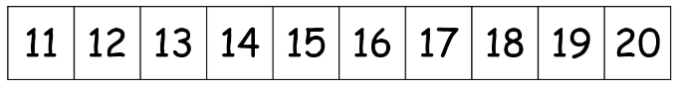
Now complete the Mathletics activity on 1 more and 2 less.

I have added 2 optional sheets which can be printed if you want to. The first sheet asks you to count the object and write the correct symbol. I have added a challenge for those of you who would like to have a go at using your knowledge of greater than and less than.
Reading
Read for AT LEAST 10 minutes every day.

I know you can do it as we would normally do a lot more when we are at school.
I would love you all to use BugClub everyday as the Bug questions teach important reading skills that we would normally be covering in lessons. Every day, I will check to see who has read and how you have got on with the questions.
If you would prefer not to use a screen to read all of the time, it is absolutely fine to read books you have at home.
Reading every day is the most important thing to do.
Phonics and Tricky ‘red’ Words
Each day, I will be giving you a sound to practice or recap. It will have the rhyme that we use to help us to learn it and some real words that contain the special friend. Have a go at reading the words and writing them making sure you use your ‘Fred Fingers’ to help you. There will also be some nonsense words to go with each sound for you to practice reading.
This week’s ‘red’ words:
are
want
do
many
any
one
anyone

Each week, there will be 7 ‘red’ words for you to learn how to read and spell. 2 of these will be words we have looked at before and 5 will be new ones. Have a go at reading them and writing them, either as a list or in a sentence – Are you a boy? Do you want any sweets? Remember capital letters, finger spaces and full stops/question marks!

English
Today we will be carrying on with the story of Jack and the Beanstalk. We are almost at the end of the story.

Before you watch the video: What do you think the golden hen will do? What might Jack do next?

As you are watching the video:
Listen and look out for how Jack manages to take the hen from the Giant.
Listen and look out for the ways the Giant’s wife shows that she agrees with Jack.

Watch this video: 12: ‘Golden eggs’ - https://www.bbc.co.uk/teach/class-clips-video/english-ks1-jack-and-the-beanstalk-pt12/zk4xvk7

After you have watched the video, have a go at answering these questions: (Tell your answers to an adult)
Why doesn’t the golden hen lay an egg for the Giant at first?
What does Jack plan to do with the magic hen when he gets back?
How does the Giant’s wife show she agrees with Jack taking the hen?
How does Jack’s Ma react when he gets back?

Activity: Make a magic creature.
Jack brings back a magic hen from the castle. Can you remember what it does? Why is it magic? Invent your own magic creature and describe what it does. You can use the sheet below to record your ideas if you want to. It’s up to you how you create your creature; you might use Lego or modelling clay or draw/paint it. Then you can write to tell me what it does.
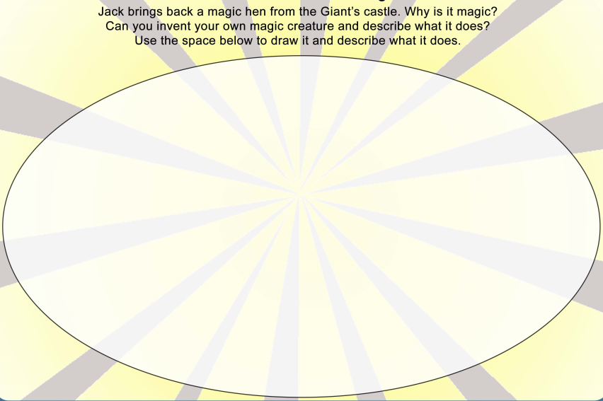

I hope you have another fantastic day of learning. Remember, we will have a zoom meeting today at 11.30am. I am looking forward to seeing you all and sharing our learning. I will also be doing a quick science lesson which will help you complete a fun science activity.

