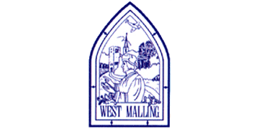
Wednesday 20th January 2021

Good morning Lime Class!

It was lovely seeing so many of you on our Zoom session yesterday! I hope you all enjoyed seeing each other and joining in with some of our learning, just like we would in class.

Please find your learning for today below.
If you have any issues, please do let me know as I am very happy to help in any way I can.
Please stay in close contact and email your learning each day to limeteacher@west-malling.kent.sch.uk
I would also love to hear about any other news or show and tell you have to share. So please send me an email today and let me know if you would like your news shared with your friends on the class webpage.
Maths
This week we are continuing to look at numbers to 20.
Today we are ordering groups of objects.

Watch this video: https://player.vimeo.com/video/483537557 (Don’t worry about doing the worksheet part)

The video will ask you to use objects to work out who has the most and the least including how many letters are in your name. There is lots of different vocabulary used in today’s video – most, more, greatest and least, fewer and smallest. Remember they mean the same thing! Listen and count carefully so you can place objects into the correct order. Use your knowledge of tens and ones to help you. It is ok to use resources like Lego/blocks to help you too!

Now complete the Mathletics test on using numbers to 20.

I have added an optional sheet which can be printed if you want to. You will notice it starts with question 2 today where you will need to use the greater than > and less than < signs. Then you can show me the numbers that are greater and less than a given number. Can you have a go at showing me all the different numbers for question 6?
Reading
Read for AT LEAST 10 minutes every day.

I know you can do it as we would normally do a lot more when we are at school.
I would love you all to use BugClub everyday as the Bug questions teach important reading skills that we would normally be covering in lessons. Every day, I will check to see who has read and how you have got on with the questions.
If you would prefer not to use a screen to read all of the time, it is absolutely fine to read books you have at home.
Reading every day is the most important thing to do.

Phonics and Tricky ‘red’ Words
Each day, I will be giving you a sound to practice or recap. It will have the rhyme that we use to help us to learn it and some real words that contain the special friend. Have a go at reading the words and writing them making sure you use your ‘Fred Fingers’ to help you. There will also be some nonsense words to go with each sound for you to practice reading.
This week’s ‘red’ words:
are
want
do
many
any
one
anyone

Each week, there will be 7 ‘red’ words for you to learn how to read and spell. 2 of these will be words we have looked at before and 5 will be new ones. Have a go at reading them and writing them, either as a list or in a sentence – Are you a boy? Do you want any sweets? Remember capital letters, finger spaces and full stops/question marks!
English
Today we will be carrying on with the story of Jack and the Beanstalk. We are very close to the end of the story!

Before you watch the video: How many times has Jack been up the beanstalk? Remember this is a traditional fairy tale. What do you predict (guess) might happen next? (This may lead you to talk about the idea of things often being in threes in fairy tales – the three little pigs, the three bears etc.). Do you know what a harp is?

As you are watching the video:
Listen and look out for the sounds and smells that are mentioned in the Giant’s castle.
Listen and look out for where Jack hides this time.

Watch this video: 13: ‘The magic harp’ - https://www.bbc.co.uk/teach/class-clips-video/english-ks1-jack-and-the-beanstalk-pt13/z77ykmn

After you have watched the video, have a go at answering these questions: (Tell your answers to an adult)
What does Jack make for the hen?
What does Jack do with the golden eggs?
Why does Jack go back to the Giant’s castle?
How does the music from the harp make the Giant feel?

Activity: Sounds and smells.
What sounds and smells are mentioned in the Giant’s castle this time? Use the sheet below to sort the phrases into ‘sounds’ and ‘smells’ words. Can you describe if they would be good or bad?
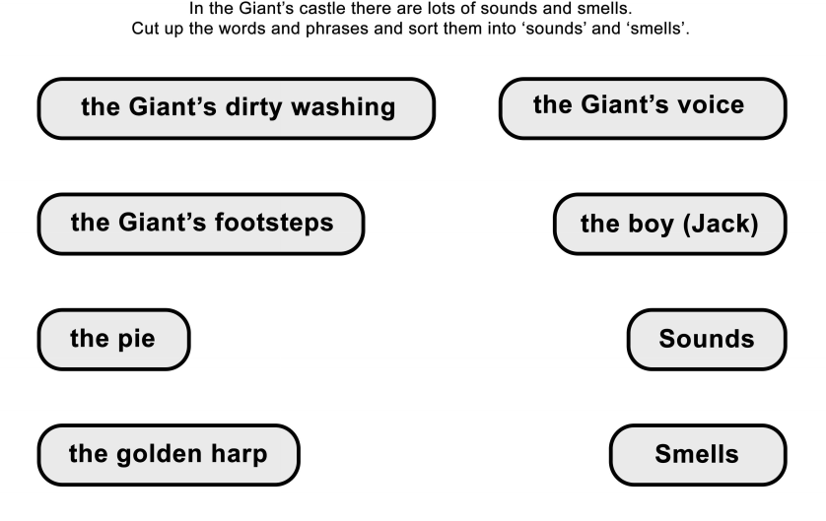

I hope you have another fantastic day of learning. Do email me if there is anything I can help you with or if you have any questions. I look forward to seeing some more of your amazing learning throughout the day.

