
Thursday 21st January 2021

Good morning Lime Class!

I hope you had another good day of learning yesterday. How did you get on with the RE lesson?

Please find your learning for today below.
If you have any issues, please do let me know as I am very happy to help in any way I can.
Please stay in close contact and email your learning each day to limeteacher@west-malling.kent.sch.uk
I would also love to hear about any other news or show and tell you have to share. So please send me an email today and let me know if you would like your news shared with your friends on the class webpage.
Maths
This week we are continuing to look at numbers to 20.
Today we are looking at ordering numbers.

Watch this video: https://player.vimeo.com/video/483539572 (Don’t worry about doing the worksheet part)

The video will ask you to order numbers from the greatest to the least/smallest and from the least/smallest to the greatest. Have a go at playing the pick a card game. Write numbers 0-20 on separate pieces of paper. Pick 3 or 4 cards and order them from the greatest to smallest and then the smallest to greatest. Try the challenge of picking 2 cards and writing the number that could go in the middle.

There are no set tasks on Mathletics but please practise the activities under Autumn – Number to 20.

Today I have added 2 optional sheets which can be printed if you want to. Questions 1 and 2 you are thinking about the largest and smallest numbers. Questions 3, 4 and 5 asks you to order numbers form the largest to the smallest. Please do use resources to help you if you want.

Reading
Read for AT LEAST 10 minutes every day.

I know you can do it as we would normally do a lot more when we are at school.
I would love you all to use BugClub everyday as the Bug questions teach important reading skills that we would normally be covering in lessons. Every day, I will check to see who has read and how you have got on with the questions.
If you would prefer not to use a screen to read all of the time, it is absolutely fine to read books you have at home.
Reading every day is the most important thing to do.
Phonics and Tricky ‘red’ Words
Each day, I will be giving you a sound to practice or recap. It will have the rhyme that we use to help us to learn it and some real words that contain the special friend. Have a go at reading the words and writing them making sure you use your ‘Fred Fingers’ to help you. There will also be some nonsense words to go with each sound for you to practice reading.
This week’s ‘red’ words:
are
want
do
many
any
one
anyone

Each week, there will be 7 ‘red’ words for you to learn how to read and spell. 2 of these will be words we have looked at before and 5 will be new ones. Have a go at reading them and writing them, either as a list or in a sentence – Are you a boy? Do you want any sweets? Remember capital letters, finger spaces and full stops/question marks!

English
Today is the last episode of our Jack and the Beanstalk story.

Before you watch the video: What do you think will happen in this last episode of the story? What do you think will happen to Jack? What do you think will happen to the Giant?

As you are watching the video:
Listen and look out for what is unusual about the harp.
Listen and look out for what happens to all the characters at the end.

Watch this video: 14: ‘We’re rich!’ - https://www.bbc.co.uk/teach/class-clips-video/english-ks1-jack-and-the-beanstalk-pt14/zdwncqt

After you have watched the video, have a go at answering these questions: (Tell your answers to an adult)
What does the harp do that spoils Jack’s plans?
What happens to the Giant?
Why is Jack happy at the end?

Activity: Story telling
Talk about how the story ends. Can you retell the whole story? Use the pictures below to help you. Start to think about the important parts of the story ready to create your own story map tomorrow.

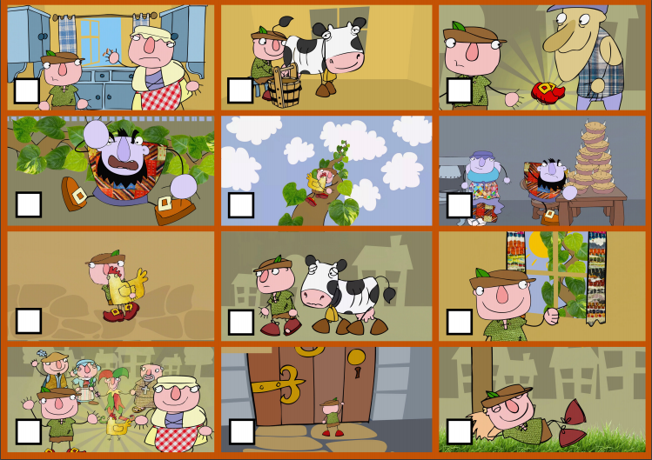

Topic - Geography
Today we are continuing with our topic Brazil. 

For this lesson, you will learn about the features of a city and find out about the different cities in Brazil. You will then compare it to a local city like London or Brighton.

There is also a quiz to do before and after the lesson to test your knowledge!

You will need a pen and some paper to complete the activities.

Here is the link to the video for you to watch: https://classroom.thenational.academy/lessons/what-are-the-features-of-cities-in-brazil-crrk4r

Mums and Dads – The video is quite long again but can be taught as 2 or even 3 parts. Here are my suggestions:
First part – Up to 5 minutes – recapping the 7 continents, looking at South America and locating Brazil.
Second Part – Up to 9:31 – Overview of some Brazilian cities.
Third part – Up to the end – looking at Rio de Janeiro and comparing with a local city. (Activity)

They will need to write 4 short sentences for today’s activities:

I live in ________________. My closest city is ________________________.

One similarity between ________________ and the cities in Brazil is _____________________.

One difference between _______________ and the cities in Brazil is _____________________.

Children can have a go at writing the whole sentences themselves, filling in the gaps or dictate their sentence to an adult to scribe.

I hope you have another fantastic day of learning. Do email me if there is anything I can help you with or if you have any questions. I look forward to seeing some more of your amazing learning throughout the day. Don’t forget our catch up zoom session tomorrow at 11.30. Remember it is ‘Fancy dress Friday’ so I can’t wait to see what you are all going to be wearing! You will find out who the Learner of the week is – it could be you!

