
Friday 22nd January 2021

Good morning Lime Class!

We have made it to the end of another week of remote teaching and learning! I hope you all have a rest this weekend.

I am looking forward to seeing you all again later on this morning (11.30) for our Friday Zoom session. Remember it is ‘Fancy Dress Friday’ so I can’t wait to see what you are dressed up as!

Please find your learning for today below.
If you have any issues, please do let me know as I am very happy to help in any way I can.
Please stay in close contact and email your learning each day to limeteacher@west-malling.kent.sch.uk
Maths
Today we have come to the end of our unit on numbers to 20 so we will be thinking about everything we have learnt last week and this week. There is a fun activity video you can watch either before or after you have completed the ‘end of unit check’ sheets.

Fun activity video – special delivery: https://player.vimeo.com/video/486866946

The video has a few activities that you can try. One of them is similar to the pick a card game that you played yesterday. There is a good one at the end where you will need a dice, ten frames and something to use as counters. You can draw the ten frames and use anything you like for counters – pasta, sweets or Lego/bricks.

There are no set tasks on Mathletics but please practise the activities under Autumn – Number to 20.

Today there are 2 sheets that I would like you to have a go at as they are our ‘end of unit check.’ There are 5 questions looking at numbers to 20 and thinking about what you now know about them. If you want to, you can try the ‘think’ question at the end explaining your answer. An adult can read the questions to you just like I would if we were at school.
Reading
Read for AT LEAST 10 minutes every day.

I know you can do it as we would normally do a lot more when we are at school.
I would love you all to use Bug Club everyday as the Bug questions teach important reading skills that we would normally be covering in lessons. Every day, I will check to see who has read and how you have got on with the questions.
If you would prefer not to use a screen to read all of the time, it is absolutely fine to read books you have at home.
Reading every day is the most important thing to do.

Phonics and Tricky ‘red’ Words
Each day, I will be giving you a sound to practice or recap. It will have the rhyme that we use to help us to learn it and some real words that contain the special friend. Have a go at reading the words and writing them making sure you use your ‘Fred Fingers’ to help you. There will also be some nonsense words to go with each sound for you to practice reading.
This week’s ‘red’ words:
are
want
do
many
any
one
anyone

Each week, there will be 7 ‘red’ words for you to learn how to read and spell. 2 of these will be words we have looked at before and 5 will be new ones. Have a go at reading them and writing them, either as a list or in a sentence – Are you a boy? Do you want any sweets? Remember capital letters, finger spaces and full stops/question marks!

English
We have now come to the end of our story of Jack and the Beanstalk. I hope you have enjoyed looking at each part of the story in detail. Today, we are going to look at the whole story and see how much you can remember to create your own version.

There is no video to watch today, but here is the link to all 14 episodes if you need to remind yourself of any parts of the story - https://www.bbc.co.uk/teach/class-clips-video/english-ks1-jack-and-the-beanstalk-home/zff42sg

Activity: Story map/writing.
Have a go at creating your own story map by drawing your own pictures of each important part of the story. If you would like to, you can then use your story map/pictures to plan and write your own version of the Jack and the Beanstalk story. There are words at the bottom of the sheet that might help you.

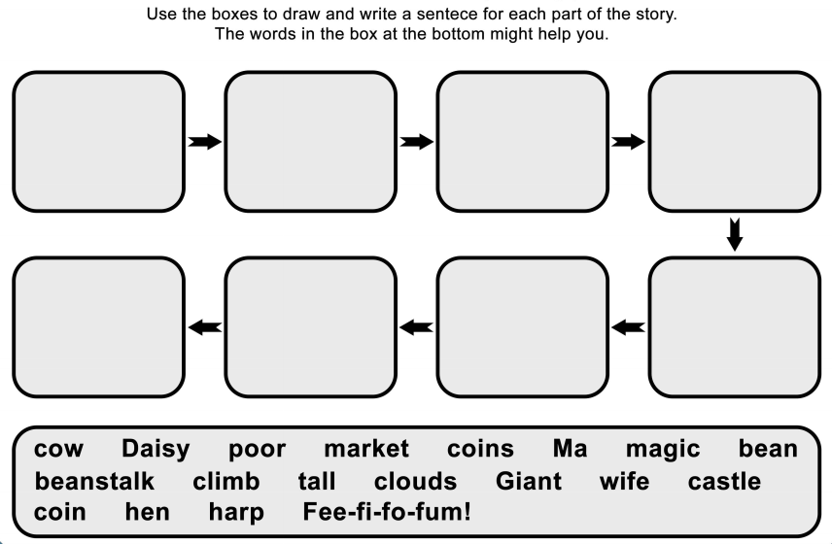
I hope you have another fantastic day of learning. Do email me if there is anything I can help you with or if you have any questions. I look forward to seeing you on Zoom later, where we will be talking about our fancy dress outfits/costumes and receiving some more of your amazing learning throughout the day. Have a lovely weekend.

