
Thursday 28th January 2021

Good morning Lime Class!

I hope you had another good day of learning yesterday. How did you get on with the RE lesson?

Please find your learning for today below.
If you have any issues, please do let me know as I am very happy to help in any way I can.
Please stay in close contact and email your learning each day to limeteacher@west-malling.kent.sch.uk
I would also love to hear about any other news or show and tell you have to share. So please send me an email today and let me know if you would like your news shared with your friends on the class webpage.
Maths
This week we are going to be looking at addition and subtraction up to 10.
Today we are comparing addition and subtraction statements.

Watch this video: https://player.vimeo.com/video/471435966

The video will ask you to use the < > = signs to compare two number sentences. It will start by using addition number sentences then you can answer question 1 on the sheet. Next, you will compare two subtraction number sentences and answer question2. Then it will move on to comparing an addition and a subtraction number sentence and then you can complete the rest of the worksheet. Remember to work out the answer to each number sentence before you compare them. Use ten frames, cubes or objects to help you.

Now complete the Mathletics task on adding to 10 word problems.

The work sheet today is the one that goes with the video. You will need to use < > = signs to compare number sentences. Questions 1 and 2 you can use the pictures on the sheet to help you work out the answers. For question 3, you may want to use cubes/objects or draw dots/lines to work out the answer to each number sentence first. Question 4, an adult can scribe your how do you know answer. You don’t need to print the worksheet and can write the answers on a piece of paper.
Reading
Read for AT LEAST 10 minutes every day.
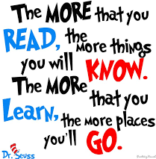
I know you can do it as we would normally do a lot more when we are at school.
I would love you all to use BugClub everyday as the Bug questions teach important reading skills that we would normally be covering in lessons. Every day, I will check to see who has read and how you have got on with the questions.
If you would prefer not to use a screen to read all of the time, it is absolutely fine to read books you have at home.
Reading every day is the most important thing to do.
Phonics and Tricky ‘red’ Words
Each day, I will be giving you a sound to practice or recap. It will have the rhyme that we use to help us to learn it and some real words that contain the special friend. Have a go at reading the words and writing them making sure you use your ‘Fred Fingers’ to help you. There will also be some nonsense words to go with each sound for you to practice reading.
This week’s ‘red’ words:
of
what
baby
all
call
tall
small
Each week, there will be 7 ‘red’ words for you to learn how to read and spell. 2 of these will be words we have looked at before and 5 will be new ones. Have a go at reading them and writing them, either as a list or in a sentence – My baby is small. My Dad is very tall. What is the time? I took all the toys! Remember capital letters, finger spaces and full stops/question marks!

English
This week we are starting something different for our English learning. We are going to be looking at recounts in the form of a diary entry. These lessons are set out in the same way we would teach them in school.

Before you watch the video: Can you remember the story of The Magic Paintbrush? Think of how you broke your recount map into those 5 different sections. Use your map and the stepping you have done to help you.

Watch this video for today’s lesson- https://classroom.thenational.academy/lessons/to-use-the-past-tense-69k30d?activity=video&step=1

The video is 16 minutes long. It could be broken into 4 parts. Here are my suggestions:
- Up to 3:55 – This is the introduction to the lesson and a recount of The Magic Paintbrush story.
- Up to 9:11 – What is the past tense? You will learn a song and think about changing the verbs from present tense to the past tense for example; paint to painted. What are verbs? Can you find them in the sentences? It will all be explained to you on the video.
- Up to 13 minutes – Shared writing – Think it! Say it! Punctuate it! When you are writing it – think it! Write it! Read it back! This includes your activity.
- Up to the end of the video – Past tense police! You will check that your sentences were changed correctly. You will also find out the answer to yesterday’s riddle. Did you guess correctly?

Activity: To change sentences so they are in the past tense.
Your activity today is to look at 4 sentences and change the verb to the past tense.

He locks me in jail.
He _____________ me in jail.

I go to the fields.
I _________ to the fields.

I trick the king.
I ______________ the king.

I change people’s lives.
I __________________ people’s lives.

Topic - Geography
Today we are continuing with our topic Brazil. 

For this lesson, we will recap our knowledge of the seven continents of the world, before zooming into South America and locating Brazil. We are going to look at a case study of Rio de Janeiro, and the different experiences people have in different parts of the city.

There is also a quiz to do before and after the lesson to test your knowledge!

You will need a pen and some paper to complete the activities.

Here is the link to the video for you to watch: https://classroom.thenational.academy/lessons/how-do-experiences-within-rio-de-janeiro-differ-68tk8d?step=2&activity=video

Mums and Dads – The video is quite long again but can be taught as 2 or even 3 parts. Here are my suggestions:
First part – Up to 8:15 – recapping the 7 continents by their shape, looking at South America and locating Brazil.
Second Part – Up to 16:36 – Case study of Rio de Janeiro to find out more about different experiences living in the city. (Sorting statements activity. See below.)
Third part – Up to the end – Going through the statements. How many did you get right? There is a final task at the end but I would like you to talk through the sentences and not worry about writing them down. The sorting the statements is the main activity I would like completed this week. Feel free to write them down if you want to though!

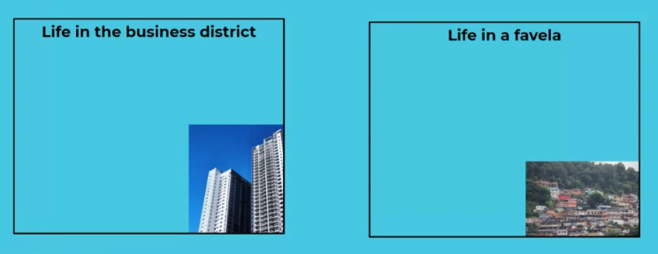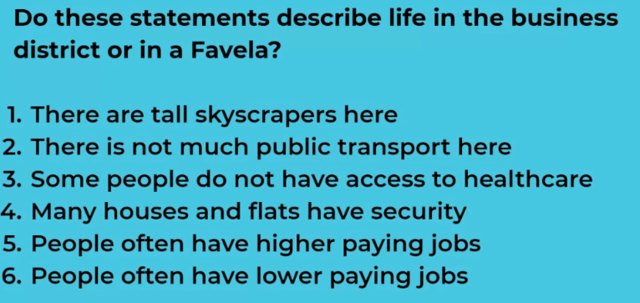

I have attached a sheet to the class webpage if you want to have a go at cutting and sticking the statements onto the sheet. You could just write the headings and copy the sentences underneath the correct one too.
I hope you have another fantastic day of learning. Do email me if there is anything I can help you with or if you have any questions. I look forward to seeing some more of your amazing learning throughout the day. Don’t forget our catch up zoom session tomorrow at 11.30. Remember we will be playing ‘BINGO’ so make sure you write down six numbers between 0 and 20 ready to play! You will also find out who the Learner of the week is – it could be you!

