
Friday 29th January 2021

Good morning Lime Class!

We have made it to the end of another week of remote teaching and learning! I hope you all have a rest this weekend.

I am looking forward to seeing you all again later on this morning (11.30) for our Friday Zoom session. Remember to have six numbers between 0 and 20 written down ready for our game of BINGO!

Please find your learning for today below.
If you have any issues, please do let me know as I am very happy to help in any way I can.
Please stay in close contact and email your learning each day to limeteacher@west-malling.kent.sch.uk

Maths
Today we have come to the end of our unit on addition and subtraction to 10 so we will be thinking about everything we have learnt over the last few weeks. There is a fun activity video you can watch and I have also added a game that you could play to practise your subtraction skills.

Fun activity video – snowflakes, snowflakes all around: https://vimeo.com/486862862

The video has a few activities that you can try and you will also be practising your knowledge of pattern, shapes and more/less. There is a good one at the end where you will need a piece of paper and some scissors to make your own shape snowflake.

Now complete the Mathletics test on addition and subtraction to 10.

Today I have added a subtraction game for you to try – Race to zero! You will need a dice and a number line or you could use number cards from 0 to 10. If you want to challenge yourself, try starting at 20.

Reading
Read for AT LEAST 10 minutes every day.

I know you can do it as we would normally do a lot more when we are at school.
I would love you all to use Bug Club everyday as the Bug questions teach important reading skills that we would normally be covering in lessons. Every day, I will check to see who has read and how you have got on with the questions.
If you would prefer not to use a screen to read all of the time, it is absolutely fine to read books you have at home.
Reading every day is the most important thing to do.

Phonics and Tricky ‘red’ Words
Each day, I will be giving you a sound to practice or recap. It will have the rhyme that we use to help us to learn it and some real words that contain the special friend. Have a go at reading the words and writing them making sure you use your ‘Fred Fingers’ to help you. There will also be some nonsense words to go with each sound for you to practice reading.
This week’s ‘red’ words:
of
what
baby
all
call
tall
small

Each week, there will be 7 ‘red’ words for you to learn how to read and spell. 2 of these will be words we have looked at before and 5 will be new ones. Have a go at reading them and writing them, either as a list or in a sentence – My baby is small. My Dad is very tall. What is the time? I took all the toys! Remember capital letters, finger spaces and full stops/question marks!

English
This week we are starting something different for our English learning. We are going to be looking at recounts in the form of a diary entry. These lessons are set out in the same way we would teach them in school.

Before you watch the video: Have you ever written in a diary - what you did, your thoughts or how you were feeling?

Watch this video for today’s lesson- https://classroom.thenational.academy/lessons/to-retrieve-information-c4tp4d?activity=video&step=1

The video is 18 minutes long. It could be broken into 3 parts. Here are my suggestions:
- Up to 3 minutes – This is the introduction to the lesson and also recapping the tricky words. Can you say a sentence for each word and have a go at writing the word down?
- Up to 11.07 – You will be reading Cedric’s diary and finding out how to use your ‘magnet eyes’ to find information. Then you will be asked 5 different questions about the diary extract. Use the text below to help you. You will need to pause the video after each question is asked.
- Up to the end of the video – This part includes the 5 questions. You don’t need to write the answers; you can just tell them to a grown up.

Activity: To draw a picture of Cedric’s day.
Your activity today is to draw a picture of Cedric’s day that he described in his diary. (See extract below). Once you have drawn your picture, have a go at labelling it using evidence from the text.

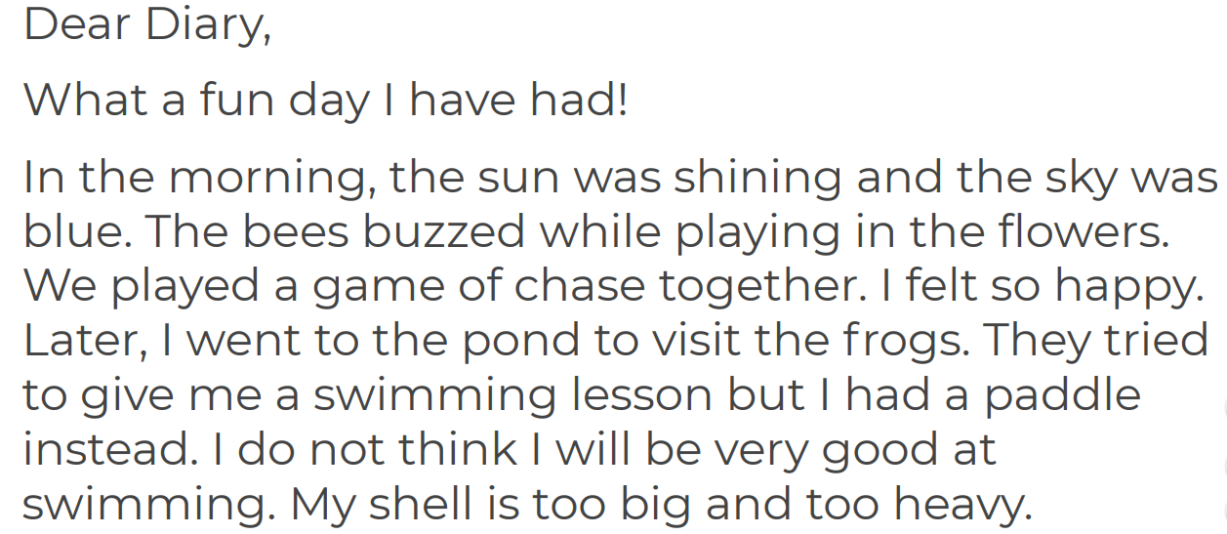
I hope you have another fantastic day of learning. Do email me if there is anything I can help you with or if you have any questions. I look forward to seeing you on Zoom later, where we will be playing BINGO and receiving some more of your amazing learning throughout the day. Have a lovely weekend.

