
Monday 1st February 2021

Good morning Lime Class!
I hope you have all had a nice weekend and are ready for another week of amazing learning.

I am looking forward to our ZOOM session tomorrow at 11.30 where we can have a quick catch up and continue with our Science learning. Try to have any work you have done nearby so that we can share each other’s learning. But most importantly I want to see you!

Please find your learning for today below.

If you have any issues, please do let me know as I am very happy to help in any way I can.
Please stay in close contact and email your learning each day to limeteacher@west-malling.kent.sch.uk
I would also love to hear about any other news or show and tell you have to share. So please send me an email and let me know if you would like your news shared with your friends on the class webpage.
Maths
This week we are going to start looking at addition and subtraction up to 20.
Today we are Adding by counting on.

Watch this video: https://vimeo.com/490879463 (Don’t worry about doing the worksheet part)

The video will show you how to start from any number and count on. You will use pictures/objects to begin with then move on to using a number line. Have a little think – what is the best/quickest way to use the number line to count on? What do we know about the numbers in an addition sum?

This week on Mathletics, I would like you to practise your quick recall of addition and subtraction on ‘Live Mathletics.’

I have added some optional sheets for you to have a go at today. There is no need to print them out. Questions 1 and 2 ask you to use a number track to count on. Fill in the numbers on the track to help you. For question 3, you will need to work out the addition number sentence then use the number line to work out the answer. Question 4 has lots of different additions for you to work out. Use a number track or number line. Remember that you can use objects and do it practically if it helps you too.
Reading
Read for AT LEAST 10 minutes every day.

I know you can do it as we would normally do a lot more when we are at school.
I would love you all to use BugClub everyday as the Bug questions teach important reading skills that we would normally be covering in lessons. Every day, I will check to see who has read and how you have got on with the questions.
If you would prefer not to use a screen to read all of the time, it is absolutely fine to read books you have at home.
Reading every day is the most important thing to do.

Phonics and Tricky ‘red’ Words
Each day, I will be giving you a sound to practice or recap. It will have the rhyme that we use to help us to learn it and some real words that contain the special friend. Have a go at reading the words and writing them making sure you use your ‘Fred Fingers’ to help you. There will also be some nonsense words to go with each sound for you to practice reading.
This week’s ‘red’ words:
they
to
your
does
some
come
here
Each week, there will be 7 ‘red’ words for you to learn how to read and spell. 2 of these will be words we have looked at before and 5 will be new ones. Have a go at reading them and writing them, either as a list or in a sentence – What does it do? Come here! They want to play. Remember capital letters, finger spaces and full stops/question marks/exclamation marks!
English
This week we will be continuing with looking at recounts in the form of a diary entry. These lessons are set out in the same way we would teach them in school.

Before you watch the video: You will need your recount map that you created last week. Can you think of any feeling words? Use the sheet below to help you.

Watch this video for today’s lesson- https://classroom.thenational.academy/lessons/to-box-up-a-recount-for-purpose-chj3ec

The video is 16 minutes long. It could be broken into 3 parts. Here are my suggestions:
- Up to 5:06 – This is the introduction to the lesson and also looking at spelling and reading 8 tricky words - happy, funny, where, when, care, cats, lunches, today. Have a go at writing the words yourself.
- Up to 8:46 – You will listen to the recount of the story then have a go at using your recount map to retell the story yourself.
- Up to the end of the video – This is the part where you will be shown how to box up the recount before you have a go.

Activity: Boxing up the recount
You can use the template that I have added to the class webpage or create your own one. I have added the one created on the video to help you. Remember you can draw pictures or write words. This will help you to write the diary entry later in the week.
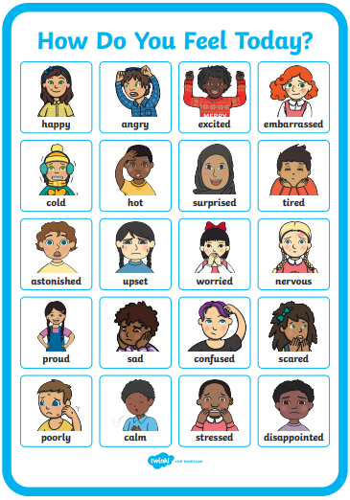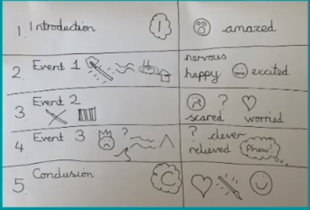
I hope you have a fantastic day of learning. Remember, we will have a zoom session tomorrow at 11.30am. Do email me if there is anything I can help you with or if you have any questions. Have a look on the class webpage as I have added another story time video.

