
Tuesday 2nd February 2021

Good morning Lime Class!

I am really looking forward to our get together over ZOOM for a catch up and a quick science lesson today at 11.30am. Try to have any work you have done nearby so that we can share each other’s learning. But most importantly I want to see you!
Please find your learning for today below.
If you have any issues, please do let me know as I am very happy to help in any way I can.
Please stay in close contact and email your learning each day to limeteacher@west-malling.kent.sch.uk
I would also love to hear about any other news or show and tell you have to share. So please send me an email today and let me know if you would like your news shared with your friends on the class webpage.
Maths
This week we are going to start looking at addition and subtraction up to 20.
Today we are Adding ones by using number bonds.

Watch this video: https://vimeo.com/490879867

In this video you will be using your knowledge of number bonds to 10 to help you work out the answers to addition number sentences. It will also help you to remember the work you did a few weeks ago on tens and ones. Then you will be using a number line to look at what is the same and different between 4 number sentences. Pause the video to complete questions 1 and 2 then 3 and 4 on the worksheet.

This week on Mathletics, I would like you to practise your quick recall of addition and subtraction on ‘Live Mathletics.’

The worksheet for today is also going to be used in tomorrow’s lesson. Questions 1, 2, 3 and 4 are for today’s video. Questions 5 and 6 will be for tomorrow.

Reading
Read for AT LEAST 10 minutes every day.
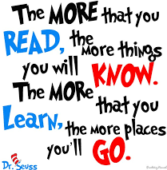
I know you can do it as we would normally do a lot more when we are at school.
I would love you all to use BugClub everyday as the Bug questions teach important reading skills that we would normally be covering in lessons. Every day, I will check to see who has read and how you have got on with the questions.
If you would prefer not to use a screen to read all of the time, it is absolutely fine to read books you have at home.
Reading every day is the most important thing to do.

Phonics and Tricky ‘red’ Words
Each day, I will be giving you a sound to practice or recap. It will have the rhyme that we use to help us to learn it and some real words that contain the special friend. Have a go at reading the words and writing them making sure you use your ‘Fred Fingers’ to help you. There will also be some nonsense words to go with each sound for you to practice reading.
This week’s ‘red’ words:
they
to
your
does
some
come
here

Each week, there will be 7 ‘red’ words for you to learn how to read and spell. 2 of these will be words we have looked at before and 5 will be new ones. Have a go at reading them and writing them, either as a list or in a sentence – What does it do? Come here! They want to play. Remember capital letters, finger spaces and full stops/question marks!
English
This week we will be continuing with looking at recounts in the form of a diary entry. These lessons are set out in the same way we would teach them in school.

Before you watch the video: Can you remember what makes a good diary entry? What do you need?

Watch this video for today’s lesson- https://classroom.thenational.academy/lessons/to-identify-features-of-a-recount-6cu68e?step=1&activity=video

The video is 15 minutes long. It could be broken into 3 parts. Here are my suggestions:
- Up to 3:30 – This is the introduction to the lesson and a game called ‘Tell and mime’. Can you guess which part of the story is being acted out? Have a go at miming parts of the story.
- Up to 10:41 – You will find out what makes a good diary entry by reading the diary of the greedy King. (Below to help you). You will think about what you need (toolkit) by being shown how to draw pictures and notes about what you have learnt.
- Up to the end of the video – This is the part where you will be told what your activity is.

Activity: Finish the toolkit picture.
You can use the template that I have added to the class webpage or create your own one. You will use the second part of the text to finish the toolkit picture. Can you spot time words, thoughts, feelings, senses and any words that show it is written in the first person – I, we, me. You can draw pictures or add words too. 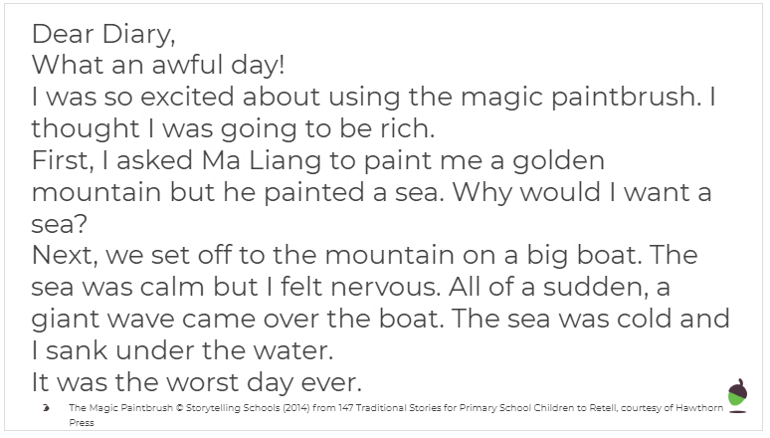
I hope you have another fantastic day of learning. Remember, we will have a zoom meeting today at 11.30am. I am looking forward to seeing you all and sharing our learning. I will also be doing a quick science lesson which will help you complete a fun activity afterwards.

