
Thursday 4th February 2021

Good morning Lime Class!

I hope you had another good day of learning yesterday. How did you get on with the RE lesson?

Please find your learning for today below.
If you have any issues, please do let me know as I am very happy to help in any way I can.
Please stay in close contact and email your learning each day to limeteacher@west-malling.kent.sch.uk
I would also love to hear about any other news or show and tell you have to share. So please send me an email today and let me know if you would like your news shared with your friends on the class webpage.
Maths
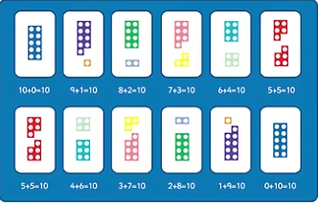
This week we are going to start looking at addition and subtraction up to 20.
Today we are looking at how to Find and Make Number Bonds.

Watch this video: https://vimeo.com/490882337 (Don’t worry about doing the worksheet part, although question 4 does relate to the video)

The video will show you how to use your knowledge of number bonds to 10 to help you work out number bonds to 20. You will be using ten frames, part whole models and bar models to show number bonds in different ways.

This week on Mathletics, I would like you to practise your quick recall of addition and subtraction on ‘Live Mathletics.’

I have added some optional sheets for you to have a go at today. There is no need to print them out. Questions 1 and 2 are using the pictures to create a number bond to 20. For question 3, you will use the ten frames, bead string and cubes to show a number bond to 20. Question 4 is colouring the number bonds that make 20. Remember to use your number bonds to 10 to help you.

Reading
Read for AT LEAST 10 minutes every day.

I know you can do it as we would normally do a lot more when we are at school.
I would love you all to use BugClub everyday as the Bug questions teach important reading skills that we would normally be covering in lessons. Every day, I will check to see who has read and how you have got on with the questions.
If you would prefer not to use a screen to read all of the time, it is absolutely fine to read books you have at home.
Reading every day is the most important thing to do.
Phonics and Tricky ‘red’ Words
Each day, I will be giving you a sound to practice or recap. It will have the rhyme that we use to help us to learn it and some real words that contain the special friend. Have a go at reading the words and writing them making sure you use your ‘Fred Fingers’ to help you. There will also be some nonsense words to go with each sound for you to practice reading.
This week’s ‘red’ words:
they
to
your
does
some
come
here

Each week, there will be 7 ‘red’ words for you to learn how to read and spell. 2 of these will be words we have looked at before and 5 will be new ones. Have a go at reading them and writing them, either as a list or in a sentence – What does it do? Come here! They want to play. Remember capital letters, finger spaces and full stops/question marks!

English
This week we are starting something different for our English learning. We are going to be looking at recounts in the form of a diary entry. These lessons are set out in the same way we would teach them in school.

Before you watch the video: It will be a good idea to have your recount map and tool kit picture to help with this next bit of writing.

Watch this video for today’s lesson- https://classroom.thenational.academy/lessons/to-write-a-recount-part-2-c4wkjd?activity=video&step=1

The video is 15 minutes long. There is quite a lot of pausing the video today and lots of writing so please just do what you can! It could be broken into 5 parts. Here are my suggestions:
- Up to 3:36 – This is the introduction to the lesson and a song to help with the second event for the diary entry.
- Up to 7:43 – Shared writing. You will write the next part of Ma Liang’s diary thinking about time words and feelings.
- Up to 10:12 – You will be writing about Ma Liang’s thoughts and feelings.
- Up to 12:51 – Think about using your senses to describe what it was like for Ma Liang in jail.
- Up to the end of the video – A challenge for you to write a sentence at the end of this part of the diary entry.

Activity: To write the second part of Ma Liang’s diary.
By the end of today’s lesson, you will have written the second event in Ma Liang’s diary. You will again think about using time words, thoughts and feelings, senses and past tense words. I have included a blank template on the class webpage you might want to use or you can just continue to write on a piece of paper. Here are some of the tricky words that might help you for each part.

Time words & feelings -  Thoughts & feelings - 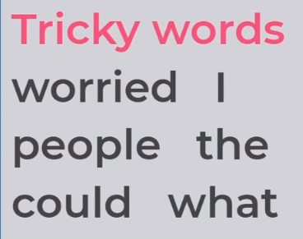

Senses - 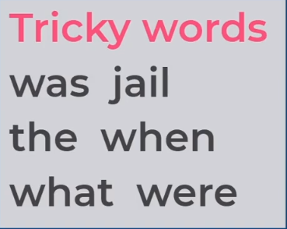 Being called to the Palace - 

Topic - Geography
Today we are continuing with our topic Brazil. 

For this lesson, we will recap our knowledge of the seven continents of the world and locating Brazil on a map. We will then zoom into the north western region of Brazil and look at an example of a community living in the Amazon rainforest.

There is also a quiz to after the lesson to test your knowledge!

You will need a pen and some paper to complete the activities.

Here is the link to the video for you to watch: https://classroom.thenational.academy/lessons/who-lives-in-the-amazon-rainforest-cnk6cd

Mums and Dads – The video is quite long again but can be taught as 3 or even 4 parts. I am aware that the children will have done lots of writing again in their English lesson today, so for the 3 pauses for sentence writing, please just talk about it with them. There is no need for them to do the writing unless of course they want to! They just need to do the challenge at the end of the video. Here are my suggestions:
First part – Up to 6:33 – recapping the 7 continents and the countries in South America. You will have an introduction to the Amazon rainforest and what it is like there. Discuss how life in West Malling is different to the Amazon rainforest.
Second Part – Up to 13:07 – Who lives in the Amazon rainforest? You will find out about the Awa tribe. Discuss how your daily routine is different.
Third part – Up to 3 minutes – How have the tribes of the indigenous communities changed over time? Discuss what the biggest problems that tribes face living in the Amazon.
Fourth part – Up to the end – Challenge – Can you draw a picture of a village in the Amazon rainforest and label it with different parts of the rainforest that tribes use in their daily lives? You can do this any way you like – so you could use paint, crayons, felt tip or even modelling clay/playdough or create a model.

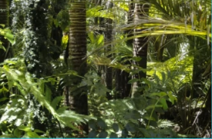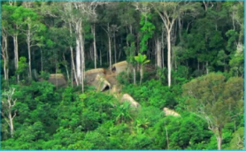

I hope you have another fantastic day of learning. Do email me if there is anything I can help you with or if you have any questions. I look forward to seeing some more of your amazing learning throughout the day. Don’t forget our catch up zoom session tomorrow at 11.30. Remember it is ‘Funny Friday’ so you could write a joke or a riddle or just wear something funny! You will also find out who the Learner of the week is – it could be you!

