
Friday 5th February 2021

Good morning Lime Class!

We have made it to the end of another week of remote teaching and learning! We are so close now to half term! I hope you all have a rest this weekend.

I am looking forward to seeing you all again later on this morning (11.30) for our Friday Zoom session. Remember it is ‘Funny Friday’ so you could write a joke or a riddle or just wear something funny!

Please find your learning for today below.
If you have any issues, please do let me know as I am very happy to help in any way I can.
Please stay in close contact and email your learning each day to limeteacher@west-malling.kent.sch.uk

Maths
This week we are going to start looking at addition and subtraction up to 20.
Today we are adding by making ten.

Watch this video: https://vimeo.com/492195871

The video will show you how to use ten frames and part whole models to make 10. Use your knowledge of number bonds to 10. You can use counters/objects to help you.

This week on Mathletics, I would like you to practise your quick recall of addition and subtraction on ‘Live Mathletics.’

Today’s worksheet is linked to the video. Do questions 1 and 2 using ten frames and then question 3 with the part whole models.

Reading
Read for AT LEAST 10 minutes every day.

I know you can do it as we would normally do a lot more when we are at school.
I would love you all to use Bug Club everyday as the Bug questions teach important reading skills that we would normally be covering in lessons. Every day, I will check to see who has read and how you have got on with the questions.
If you would prefer not to use a screen to read all of the time, it is absolutely fine to read books you have at home.
Reading every day is the most important thing to do.

Phonics and Tricky ‘red’ Words
Each day, I will be giving you a sound to practice or recap. It will have the rhyme that we use to help us to learn it and some real words that contain the special friend. Have a go at reading the words and writing them making sure you use your ‘Fred Fingers’ to help you. There will also be some nonsense words to go with each sound for you to practice reading.
This week’s ‘red’ words:
they
to
your
does
some
come
here

Each week, there will be 7 ‘red’ words for you to learn how to read and spell. 2 of these will be words we have looked at before and 5 will be new ones. Have a go at reading them and writing them, either as a list or in a sentence – What does it do? Come here! They want to play. Remember capital letters, finger spaces and full stops/question marks!

English
Today is our last lesson on writing a recount. I have been so impressed with how well you have done with this as I know in the last few lessons you have done so much writing! By the end of today you should have written the whole of Ma Liang’s diary entry.

Before you watch the video: Have your toolkit ready and your diary entry so far.

Watch this video for today’s lesson- https://classroom.thenational.academy/lessons/to-write-a-recount-c8u3er?activity=video&step=1

The video is 14 minutes long. It could be broken into 4 parts. Here are my suggestions:
- Up to 2:29 – This is the introduction to the lesson and also recapping the tricky words. Can you say a sentence for each word and have a go at writing the word down?
- Up to 7:55 – Sing the diary song. Shared writing. Write the information about the third event using time words and feelings.
- Up to 12.29 – You will write the conclusion – what happens to the King? Make sure you add thoughts and feelings.
- Up to the end – Finish writing Ma Liang’s diary OR have a go at writing a diary entry about one of your days this week.

Activity: To finish writing Ma Liang’s diary.
Today you will write about the third event and the conclusion to finish the diary entry.

Third event Conclusion
time words & feelings 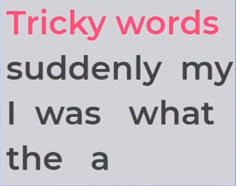 thoughts & feelings 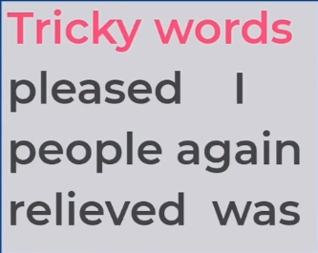



I hope you have another fantastic day of learning. Do email me if there is anything I can help you with or if you have any questions. I look forward to seeing you on Zoom later and receiving some more of your amazing learning throughout the day. Have a lovely weekend.

