
Monday 8th February 2021

Good morning Lime Class!
I hope you have all had a nice weekend and are ready for our last week of learning for this term!

I am looking forward to our ZOOM session tomorrow at 11.30 where we can have a quick catch up and continue with our Science learning. Try to have any work you have done nearby so that we can share each other’s learning. But most importantly I want to see you!

Please find your learning for today below.

If you have any issues, please do let me know as I am very happy to help in any way I can.
Please stay in close contact and email your learning each day to limeteacher@west-malling.kent.sch.uk
I would also love to hear about any other news or show and tell you have to share. So please send me an email and let me know if you would like your news shared with your friends on the class webpage.
Maths
This week we are continuing to look at addition and subtraction up to 20.
Today we are Subtracting but not crossing 10.

Watch this video: https://vimeo.com/492197096 (Don’t worry about doing the worksheet part)

The video will show you how to use pictures and 10 frames to create and work out a subtraction number sentence. Then it will move on to show you how to use part whole models to help work out the answers. Use your number facts up to 10 to help you work out the number sentences up to 20.

Now complete the mathletics tasks I have set you on adding 3 numbers using bonds to 10.

I have added some optional sheets for you to have a go at today. There is no need to print them out. Questions 1 and 2 ask you to create a subtraction number sentence using pictures and ten frames. Questions 3 and 4 ask you to complete the number sentences using ten frames, bead strings and a number track to help you.
Reading
Read for AT LEAST 10 minutes every day.
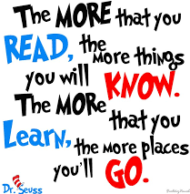
I know you can do it as we would normally do a lot more when we are at school.
I would love you all to use BugClub everyday as the Bug questions teach important reading skills that we would normally be covering in lessons. Every day, I will check to see who has read and how you have got on with the questions.
If you would prefer not to use a screen to read all of the time, it is absolutely fine to read books you have at home.
Reading every day is the most important thing to do.
Phonics and Tricky ‘red’ Words
Each day, I will be giving you a sound to practice or recap. It will have the rhyme that we use to help us to learn it and some real words that contain the special friend. Have a go at reading the words and writing them making sure you use your ‘Fred Fingers’ to help you. There will also be some nonsense words to go with each sound for you to practice reading.
This week’s ‘red’ words:
I
other
mother
father
two
my
buy
Each week, there will be 7 ‘red’ words for you to learn how to read and spell. 2 of these will be words we have looked at before and 5 will be new ones. Have a go at reading them and writing them, either as a list or in a sentence – I have two cats. What can I buy? My Mother is sad. Remember capital letters, finger spaces and full stops/question marks/exclamation marks!

English
You have all worked so hard with your English work this term and have produced some fantastic writing. So I thought that we could make it a bit more fun and easier for you to complete over the next few days.
This week we will be looking at Chinese New Year. We will be finding out about the animal zodiac and also how it is celebrated.

Before you watch my video on the webpage – Have a think about what you know about Chinese New Year already? Can you name any of the animals in the Chinese zodiac? Do you know what year you were born in?

After you have watched my video of the Chinese New Year story – Have a go at retelling the story. Can you remember the order the animals finished in? Have a think about what happens at the beginning of the story and at the end. Use the sequence cards below to help you.

Activity: Write a review of the Chinese New Year story.
I have attached a template to the class webpage that you can use if you want to. Think about these questions – What is the setting? Who is the main character? What happens first? What happens next? What happens last? You might like to talk about the character’s personalities and how they must have felt. Did their actions have any consequences?

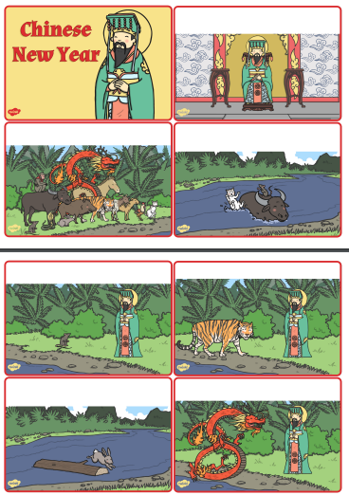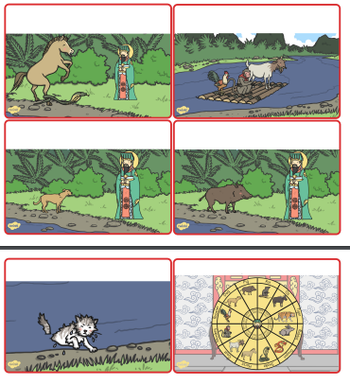
I hope you have a fantastic day of learning. Remember, we will have a zoom session tomorrow at 11.30am. Do email me if there is anything I can help you with or if you have any questions.

