
Tuesday 9th February 2021

Good morning Lime Class!

I am really looking forward to our get together over ZOOM for a catch up and a quick science lesson today at 11.30am. Try to have any work you have done nearby so that we can share each other’s learning. But most importantly I want to see you!
Please find your learning for today below.
If you have any issues, please do let me know as I am very happy to help in any way I can.
Please stay in close contact and email your learning each day to limeteacher@west-malling.kent.sch.uk
I would also love to hear about any other news or show and tell you have to share. So please send me an email today and let me know if you would like your news shared with your friends on the class webpage.
Maths
This week we are continuing to look at addition and subtraction up to 20.
Today we are beginning to look at Subtraction crossing 10.

Watch this video: https://vimeo.com/497919464

In this video you will starting by using a number story to create a subtraction number sentence and then use a number line to count back. Then it will move on to using a number line but counting back to 10 first. Finally, it will show you how to partition the second number of the subtraction number sentence so you can count back to 10 first on the number line. Pause the video to complete questions 1 and 2 then 3 and 4 on the worksheet.

Now complete the mathletics tasks I have set you on all about 20.

The work sheet today is the one that goes with the video. You don’t need to print the worksheet and can write the answers on a piece of paper.

Reading
Read for AT LEAST 10 minutes every day.

I know you can do it as we would normally do a lot more when we are at school.
I would love you all to use BugClub everyday as the Bug questions teach important reading skills that we would normally be covering in lessons. Every day, I will check to see who has read and how you have got on with the questions.
If you would prefer not to use a screen to read all of the time, it is absolutely fine to read books you have at home.
Reading every day is the most important thing to do.

Phonics and Tricky ‘red’ Words
Each day, I will be giving you a sound to practice or recap. It will have the rhyme that we use to help us to learn it and some real words that contain the special friend. Have a go at reading the words and writing them making sure you use your ‘Fred Fingers’ to help you. There will also be some nonsense words to go with each sound for you to practice reading.
This week’s ‘red’ words:
I
other
mother
father
two
my
buy

Each week, there will be 7 ‘red’ words for you to learn how to read and spell. 2 of these will be words we have looked at before and 5 will be new ones. Have a go at reading them and writing them, either as a list or in a sentence – I have two cats. What can I buy? My Mother is sad. Remember capital letters, finger spaces and full stops/question marks!

English
You have all worked so hard with your English work this term and have produced some fantastic writing. So I thought that we could make it a bit more fun and easier for you to complete over the next few days.
This week we will be looking at Chinese New Year. We will be finding out about the animal zodiac and also how it is celebrated.

Before you watch my video on the webpage – Can you remember the Chinese New Year story from yesterday? What animals were there? What order did the animals finish the race? Now watch the story video again so it is fresh in your mind.

After you have watched my video of the Chinese New Year story – Look at the 3 pictures below. Can you talk about what is happening at each part of the story?

Activity: Write a sentence about 3 parts of the story.
I have attached a template to the class webpage that you can use if you want to. Think of a sentence or sentences to write for each of these 3 pictures. Think it, say it, write it! Remember to use a capital letter at the beginning and a full stop at the end. Don’t forget your finger spaces too!
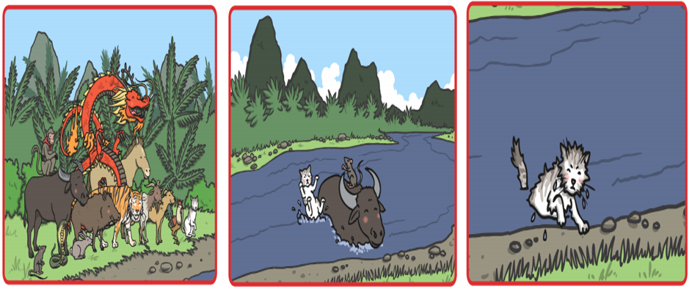
I hope you have another fantastic day of learning. Remember, we will have a zoom meeting today at 11.30am. I am looking forward to seeing you all and sharing our learning. I will also be doing a quick science lesson which will help you complete an activity afterwards.

