
Wednesday 10th February 2021

Good morning Lime Class!

It was lovely seeing so many of you on our Zoom session yesterday! I hope you all enjoyed seeing each other and joining in with some of our learning, just like we would in class.

Please find your learning for today below.
If you have any issues, please do let me know as I am very happy to help in any way I can.
Please stay in close contact and email your learning each day to limeteacher@west-malling.kent.sch.uk
I would also love to hear about any other news or show and tell you have to share. So please send me an email today and let me know if you would like your news shared with your friends on the class webpage.
Maths
This week we are continuing to look at addition and subtraction up to 20.
Today we are continuing with Subtraction crossing 10.

Watch this video: https://vimeo.com/497919984

The video will ask you to compare amounts using ten frames and counters. It will then ask you how many more? You will be shown different ways to make this into a subtraction number sentence. Then you will compare amounts using objects. Use the numbers in the question to help you make a subtraction number sentence. Start with the biggest number then take away then smallest number. How many are left? Use objects to help you.

Now complete the mathletics tasks I have set you on subtracting from 20.

The work sheet today is the one that goes with the video. You don’t need to print the worksheet and can write the answers on a piece of paper. Please stop watching the video when it says to pause to do question 3 on the worksheet as the last part of the video has a mistake in it and will confuse you!

Reading
Read for AT LEAST 10 minutes every day.

I know you can do it as we would normally do a lot more when we are at school.
I would love you all to use BugClub everyday as the Bug questions teach important reading skills that we would normally be covering in lessons. Every day, I will check to see who has read and how you have got on with the questions.
If you would prefer not to use a screen to read all of the time, it is absolutely fine to read books you have at home.
Reading every day is the most important thing to do.
Phonics and Tricky ‘red’ Words
Each day, I will be giving you a sound to practice or recap. It will have the rhyme that we use to help us to learn it and some real words that contain the special friend. Have a go at reading the words and writing them making sure you use your ‘Fred Fingers’ to help you. There will also be some nonsense words to go with each sound for you to practice reading.
This week’s ‘red’ words:
I
other
mother
father
two
my
buy

Each week, there will be 7 ‘red’ words for you to learn how to read and spell. 2 of these will be words we have looked at before and 5 will be new ones. Have a go at reading them and writing them, either as a list or in a sentence – I have two cats. What can I buy? My Mother is sad. Remember capital letters, finger spaces and full stops/question marks!

English
You have all worked so hard with your English work this term and have produced some fantastic writing. So I thought that we could make it a bit more fun and easier for you to complete over the next few days.
This week we will be looking at Chinese New Year. Today you will be finding out about how Chinese New Year is celebrated.

Before you watch my video on the webpage – What do you do to celebrate our New year in December? Do you know any Chinese New Year activities that show how they celebrate it? Where might they visit? What things might they do to prepare for their New Year?

After you have watched my video of how Chinese New Year is celebrated – Look at the 4 pictures below. Can you talk about what they are and how they are linked to celebrations for Chinese New Year?

Activity: Write a sentence about the 4 celebrations.
I have attached a template to the class webpage that you can use if you want to. Think of a sentence or sentences to write for each of these 4 pictures to show what they are doing to celebrate Chinese New Year. Think it, say it, write it! There are words on the sheet that you can use to help you. Remember to use a capital letter at the beginning and a full stop at the end. Don’t forget your finger spaces too!
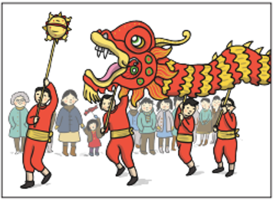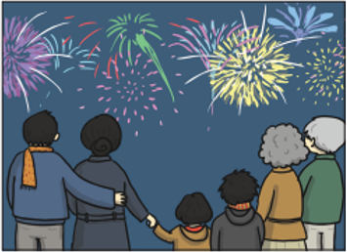
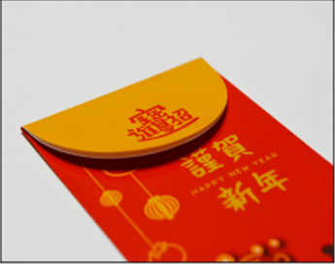

I hope you have another fantastic day of learning. Do email me if there is anything I can help you with or if you have any questions. Mums and Dads – You should have hopefully received an email with the ‘Crazy Hair’ Zoom details for Thursday and the whole school worship on Friday. Do please let me know if you didn’t receive it and I will resend it to you.

