
Thursday 11th February 2021

Good morning Lime Class!

I hope you had another good day of learning yesterday. How did you get on with the last RE lesson?

Please find your learning for today below.
If you have any issues, please do let me know as I am very happy to help in any way I can.
Please stay in close contact and email your learning each day to limeteacher@west-malling.kent.sch.uk
I would also love to hear about any other news or show and tell you have to share. So please send me an email today and let me know if you would like your news shared with your friends on the class webpage.

Maths
This week we are continuing to look at addition and subtraction up to 20.
Today we are looking at related facts.

Watch this video: https://vimeo.com/497920336

The video will show you how to use ten frames to fill in a part whole model so that you find the 2 parts and the whole number. From this part whole model, you can create 4 addition number sentences and then 4 subtraction number sentences. These are called fact families. Then you will be shown how to use a bar model to show a fact family. You can create 2 addition and 2 subtraction number sentences. Can you fill in the missing numbers using the bar model to help?

Now complete the mathletics tasks I have set you on related facts.

Today’s worksheet goes alongside the video. You will be using ten frames, part whole models and bar models to create fact families. Remember you are only using the same 3 numbers from each model.

Reading
Read for AT LEAST 10 minutes every day.

I know you can do it as we would normally do a lot more when we are at school.
I would love you all to use BugClub everyday as the Bug questions teach important reading skills that we would normally be covering in lessons. Every day, I will check to see who has read and how you have got on with the questions.
If you would prefer not to use a screen to read all of the time, it is absolutely fine to read books you have at home.
Reading every day is the most important thing to do.

Phonics and Tricky ‘red’ Words
Each day, I will be giving you a sound to practice or recap. It will have the rhyme that we use to help us to learn it and some real words that contain the special friend. Have a go at reading the words and writing them making sure you use your ‘Fred Fingers’ to help you. There will also be some nonsense words to go with each sound for you to practice reading.
This week’s ‘red’ words:
I
other
mother
father
two
my
buy

Each week, there will be 7 ‘red’ words for you to learn how to read and spell. 2 of these will be words we have looked at before and 5 will be new ones. Have a go at reading them and writing them, either as a list or in a sentence – I have two cats. What can I buy? My Mother is sad. Remember capital letters, finger spaces and full stops/question marks!

English
You have all worked so hard with your English work this term and have produced some fantastic writing. So I thought that we could make it a bit more fun and easier for you to complete over the next few days.
This week we will be looking at Chinese New Year. Today you will be seeing how Chinese New Year is celebrated.

Before you watch these videos – Can you remember what activities they do to celebrate Chinese New Year? What colours are important? Where do they visit?

Now watch these 2 video clips to show how Abbie and her brother prepare for Chinese New Year and how they celebrate it – https://www.bbc.co.uk/cbeebies/watch/chinese-new-year?collection=chinese-lunar-new-year

After you have watched the video clips – Look at the examples below and of some Chinese (mandarin) letters and numbers. What is different compared to the letters and numbers we write? Is there anything that is the same?

Activity: Have a go at doing some Chinese writing!
Use black paint, black felt tip pen or a whiteboard pen to try writing some of the Chinese symbols/letters. Look carefully at the shapes that are used and where each line goes.






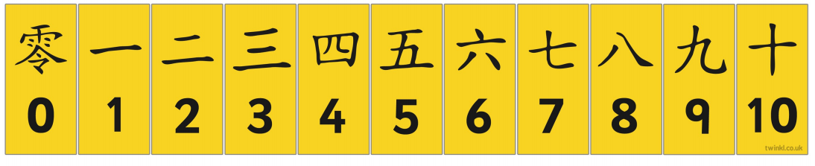

Topic - Geography
Today we are finishing our topic on Brazil. 

For this lesson, we will recap our knowledge of the seven continents of the world and locating Brazil on a map. We will combine all of our learning in this unit to explain the diversity of Brazil.

Don’t forget to do the quiz after the lesson to test your knowledge!

You will need a pen and some paper to complete the activities.

Here is the link to the video for you to watch: https://classroom.thenational.academy/lessons/why-is-brazil-difficult-to-describe-74vpat?activity=video&step=2&view=1

Mums and Dads – The video is quite long again but can be taught as 3 or even 4 parts. Here are my suggestions:
First part – Up to 5:36 – recapping the 7 continents and the countries in South America and then locating Brazil.
Second Part – Up to 09:22 – Why is the geography of Brazil so diverse? You will answer true and false questions.
Third part – Up to 12:06 – What different physical features can we recognise in Brazil? For the task, please just talk about the word you would choose to complete each sentence about the climate and features of Brazil.
Fourth part – Up to the end – What different human features can we identify on Brazil? For the task at the end, please complete the activity sheet below telling me 3 things that you have learnt about Brazil in this terms lessons. (There is a bigger version saved on the class webpage of you would like to use it). Don’t worry about doing the one that is explained at the end of the video.
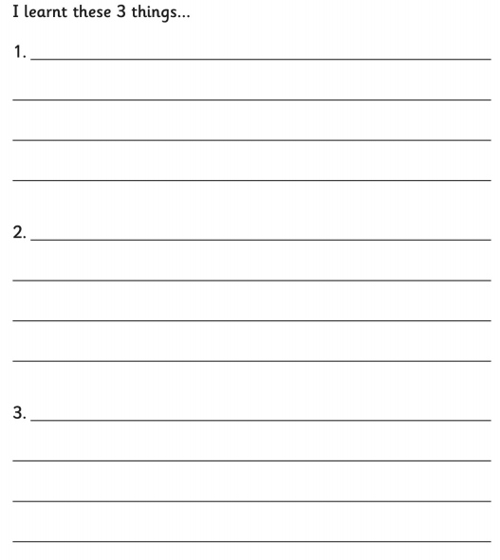

I hope you have another fantastic day of learning. Do email me if there is anything I can help you with or if you have any questions. I look forward to seeing some more of your amazing learning throughout the day. Don’t forget tomorrow is ‘no screen’ Friday so look out for some ideas of things that you could do instead on the class webpage. Remember whole school worship with Mr Rye is at 10.30 tomorrow too.

