
Monday 22nd February 2021

Good morning Lime Class!
I hope you have all had a nice half term and are ready for the start of a new term. Hopefully we can all be back together at school very soon!

I am looking forward to our ZOOM session tomorrow at 11.30 where we can have a quick catch up and start with our new topic learning. Try to have any work you have done nearby so that we can share each other’s learning. But most importantly I want to see you!

Please find your learning for today below.

If you have any issues, please do let me know as I am very happy to help in any way I can.
Please stay in close contact and email your learning each day to limeteacher@west-malling.kent.sch.uk
I would also love to hear about any other news or show and tell you have to share. So please send me an email and let me know if you would like your news shared with your friends on the class webpage.
Maths
This week we are starting a new unit of Length and Height.
Today we are Comparing Lengths.

Watch this video: https://vimeo.com/507433257

The video will show you what words we can use to help us to compare lengths. Can you think of any words we might use? You will then be shown how to measure and compare which object is the longest and the shortest. There are 2 activities on the video for you to try. You will need a spoon. Can you find 3 things that are longer and 3 things that are shorter than your spoon?

Now complete the mathletics tasks I have set you on Everyday length.

There are no written activities for you today as I would like you to do the activities from the video. If you want to continue your learning on length, have a go at finding some objects in your house and putting them in order of length. How do you know which is the longest/longer or shortest/shorter?
Reading
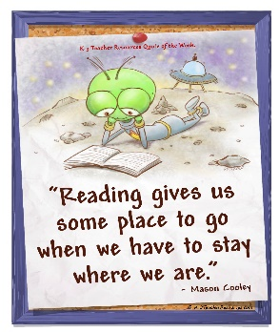
Read for AT LEAST 10 minutes every day.
I know you can do it as we would normally do a lot more when we are at school.
I would love you all to use BugClub everyday as the Bug questions teach important reading skills that we would normally be covering in lessons. Every day, I will check to see who has read and how you have got on with the questions.
If you would prefer not to use a screen to read all of the time, it is absolutely fine to read books you have at home.
Reading every day is the most important thing to do.
Phonics and Tricky ‘red’ Words
Each day, I will be giving you a sound to practice or recap. It will have the rhyme that we use to help us to learn it and some real words that contain the special friend. Have a go at reading the words and writing them making sure you use your ‘Fred Fingers’ to help you. There will also be some nonsense words to go with each sound for you to practice reading.
This week’s ‘red’ words:
I
the
you
your
said
was
are
Each week, there will be 7 ‘red’ words for you to practise to read and spell. These will be words we have looked at before so have a go at reading them and writing them, as a list and in a sentence – I was in the pool. You are the best! “Get your bag” said Mum. Are you sad? Remember capital letters, finger spaces and full stops/question marks/exclamation marks!
English
This week we are starting something different for our English learning. We are going to be looking at a story about Anansi and Tiger. These lessons are set out in the same way we would teach them in school.

Before you watch the video: Have you read a story about Anansi before? Can you think of any stories where they teach you a lesson; for example, Elmer – that story teaches us that it’s ok to be different and you should never be afraid to be yourself.

Watch this video for today’s lesson- https://classroom.thenational.academy/lessons/to-listen-and-respond-to-a-story-6wtpcr?activity=video&step=1

The video is 21 minutes long. It could be broken into 3 parts. Here are my suggestions:
- Up to 8:33 – This is the introduction to the lesson where you will learn a song about creating action packed stories. You will also have a look at spelling compound words – putting 2 words together to make one. Read the pictures to put into one word. (snow and ball = snowball).
- Up to 12:30 – You will listen to the story of Anansi and Tiger being told. Listen carefully as you will need to use the story to help you complete todays activity.
- Up to the end of the video – This is the part where you will be shown how to create a plot matrix of the story so that you understand all the different parts of it. It goes through each part of the plot matrix at the end.
Fun spider fact at the end – can you guess how many different kinds of spiders there are in the world?

Activity: Create your own plot matrix of Anansi and Tiger.
You can use the template that I have added to the class webpage or create your own one. Have a go at drawing a picture and writing a label for each of the 6 different parts. Here is the completed one from the video to help you.
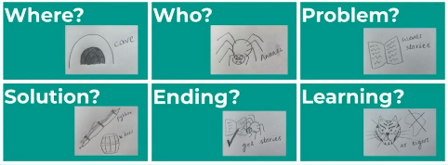

I hope you have a fantastic first day back of learning. Remember, we will have a zoom session tomorrow at 11.30am. Do email me if there is anything I can help you with or if you have any questions.

