
Tuesday 23rd February 2021

Good morning Lime Class!

I am really looking forward to our get together over ZOOM for a catch up and a quick History lesson to introduce our new topic today at 11.30am. Try to have any work you have done nearby so that we can share each other’s learning. But most importantly I want to see you!
Please find your learning for today below.

If you have any issues, please do let me know as I am very happy to help in any way I can.
Please stay in close contact and email your learning each day to limeteacher@west-malling.kent.sch.uk
I would also love to hear about any other news or show and tell you have to share. So please send me an email today and let me know if you would like your news shared with your friends on the class webpage.

Maths
This week we are starting a new unit of Length and Height.
Today we are Comparing Heights.

Watch this video: https://vimeo.com/507433540

The video will show you what words we can use to help us to compare heights. Can you think of any words we might use? You will then be shown how to measure and compare who is the tallest and the shortest. There are 3 activities on the video for you to try. Can you find 3 things that are shorter than you and 3 things that are taller than you and 3 things that are the same height as you? Remember to stand up straight and side to side!

Now complete the mathletics tasks I have set you on Comparing length.

There are no written activities for you today as I would like you to do the activities from the video. If you want to continue your learning on height, have a go at finding some objects in your house and putting them in order of height. How do you know which is the tallest/taller or shortest/shorter?

Reading
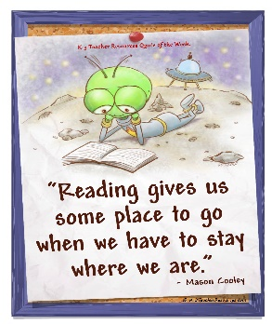
Read for AT LEAST 10 minutes every day.
I know you can do it as we would normally do a lot more when we are at school.
I would love you all to use BugClub everyday as the Bug questions teach important reading skills that we would normally be covering in lessons. Every day, I will check to see who has read and how you have got on with the questions.
If you would prefer not to use a screen to read all of the time, it is absolutely fine to read books you have at home.
Reading every day is the most important thing to do.

Phonics and Tricky ‘red’ Words
Each day, I will be giving you a sound to practice or recap. It will have the rhyme that we use to help us to learn it and some real words that contain the special friend. Have a go at reading the words and writing them making sure you use your ‘Fred Fingers’ to help you. There will also be some nonsense words to go with each sound for you to practice reading.
This week’s ‘red’ words:
I
the
you
your
said
was
are

Each week, there will be 7 ‘red’ words for you to practise to read and spell. These will be words we have looked at before so have a go at reading them and writing them, as a list and in a sentence – I was in the pool. You are the best! “Get your bag” said Mum. Are you sad? Remember capital letters, finger spaces and full stops/question marks/exclamation marks!

English
This week we are starting something different for our English learning. We are going to be looking at a story about Anansi and Tiger. These lessons are set out in the same way we would teach them in school.

Before you watch the video: Did you think about how many different types of spiders there are in the world? Can you remember what a story map is and how you use it? What can you remember about the Anansi and Tiger story?

Watch this video for today’s lesson- https://classroom.thenational.academy/lessons/to-tell-a-story-from-memory-74ukge?activity=video&step=1

The video is 20 minutes long. It could be broken into 3 parts. Here are my suggestions:
- Up to 6 minutes – This is the introduction where you can join in with the story of Anansi and Tiger. How much can you remember from yesterday?
- Up to 13:02 – You will map the story and then have a go at creating your own story map. Remember to keep your drawings simple as they are only for you to follow. Have a look at the story map below to help you.
- Up to the end of the video – This is the part where you will step the story. You will need a bit of space. Then you will have a go at stepping the story yourself.
Fun spider fact at the end – can you guess how many eggs a spider lays?

Activity: Create your own story map and think of actions to step the story.
Use the story map below to help you create your own one. Can you use your one to retell the story of Anansi and Tiger? Have a go at stepping the story yourself. Think of actions and a word or phrase for each part. Challenge – Can you step the story with just actions? Make sure you use your face to show your feelings!
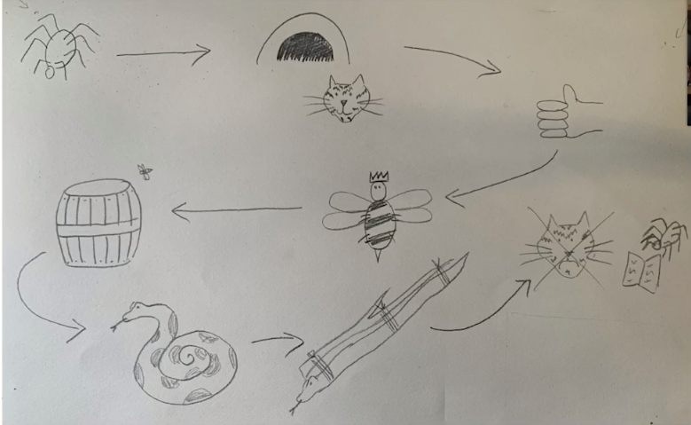
I hope you have another fantastic day of learning. Remember, we will have a zoom meeting today at 11.30am. I am looking forward to seeing you all and sharing our learning. I will also be doing a quick History lesson which will help you complete an activity afterwards.

