
Wednesday 24th February 2021

Good morning Lime Class!

It was lovely seeing so many of you on our Zoom session yesterday! I hope you all enjoyed seeing each other and joining in with some of our learning, just like we would in class.

Please find your learning for today below.
If you have any issues, please do let me know as I am very happy to help in any way I can.
Please stay in close contact and email your learning each day to limeteacher@west-malling.kent.sch.uk
I would also love to hear about any other news or show and tell you have to share. So please send me an email today and let me know if you would like your news shared with your friends on the class webpage.
Maths
This week we are starting a new unit of Length and Height.
Today we are Comparing Lengths and Heights.

Watch this video: https://vimeo.com/507943851

The video will ask you to look at the length and height of cubes, people and objects and choose which is the tallest and the shortest. Then it will move on to asking you to order 3 objects from the shortest to the tallest and from the longest to the shortest. You will then see some animals and answer some questions about their height – who is the cat taller than? Then you can have a go at using the animals to create your own sentences using the words tallest and shortest.

Today on Mathletics, I would like you to practise your quick recall of addition and subtraction on ‘Live Mathletics.’

The work sheet today is the one that goes with the video. You don’t need to print the worksheet and can write the answers on a piece of paper.

Reading
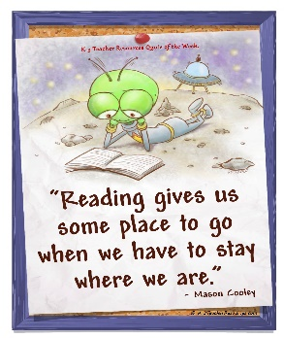
Read for AT LEAST 10 minutes every day.
I know you can do it as we would normally do a lot more when we are at school.
I would love you all to use BugClub everyday as the Bug questions teach important reading skills that we would normally be covering in lessons. Every day, I will check to see who has read and how you have got on with the questions.
If you would prefer not to use a screen to read all of the time, it is absolutely fine to read books you have at home.
Reading every day is the most important thing to do.

Phonics and Tricky ‘red’ Words
Each day, I will be giving you a sound to practice or recap. It will have the rhyme that we use to help us to learn it and some real words that contain the special friend. Have a go at reading the words and writing them making sure you use your ‘Fred Fingers’ to help you. There will also be some nonsense words to go with each sound for you to practice reading.
This week’s ‘red’ words:
I
the
you
your
said
was
are
Each week, there will be 7 ‘red’ words for you to practise to read and spell. These will be words we have looked at before so have a go at reading them and writing them, as a list and in a sentence – I was in the pool. You are the best! “Get your bag” said Mum. Are you sad? Remember capital letters, finger spaces and full stops/question marks/exclamation marks!

English
This week we are starting something different for our English learning. We are going to be looking at a story about Anansi and Tiger. These lessons are set out in the same way we would teach them in school.

Before you watch the video: Did you guess how many eggs a spider can lay? What can you remember about the Anansi and Tiger story? You will need your story map from yesterday to help you. Can you remember any words we could use at the beginning of a question?

Watch this video for today’s lesson- https://classroom.thenational.academy/lessons/to-role-play-action-clearly-in-a-story-6hgk0c?activity=video&step=1

The video is 23 minutes long. It could be broken into 4 parts. Here are my suggestions:
- Up to 3:33 – This is the introduction where you practise the action song from Mondays lesson that will help you to write your action tool kit.
- Up to 8:17 – You will practise compound words – looking at 2 pictures that go together to make 1 word. Then you are set a challenge. Have a go at reading the 9 different short words. Can you put them together to make compound words?
- Up to the 16:59 – Hot seating. After watching some examples, it will then be your go to role play as the Queen Bee.
- Up to the end of the video – You will learn the chorus for a new song about Anansi: Anansi the spider he was full of tricks, Anansi the spider always full of tricks!
Fun spider fact at the end – how big of an orb web do you think a Darwin Bark spider can make?

Activity: Role play as the Queen Bee.
Get a grown up or a teddy/puppet to ask you questions and you answer in role as the Queen Bee. Remember to use a good Queen Bee voice so you can really get into the role!

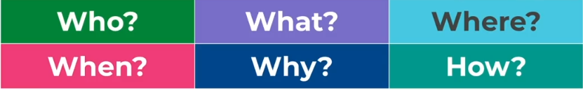
I hope you have another fantastic day of learning. Do email me if there is anything I can help you with or if you have any questions.

