
Thursday 25th February 2021

Good morning Lime Class!

I hope you had another good day of learning yesterday. How did you get on with the RE lesson?

Please find your learning for today below.
If you have any issues, please do let me know as I am very happy to help in any way I can.
Please stay in close contact and email your learning each day to limeteacher@west-malling.kent.sch.uk
I would also love to hear about any other news or show and tell you have to share. So please send me an email today and let me know if you would like your news shared with your friends on the class webpage.
Maths
This week we are starting a new unit of Length and Height.
Today we are Measuring Lengths using non-standard measures.

Watch this video: https://vimeo.com/507969952

The video will show you how to measure the length and height of different objects and what kind of things you could use to measure them with. What objects can you find to measure with? It will then show you how to use blocks/cubes to measure your spoon. You could use Lego, building bricks or counters when you measure your spoon. Remember – when you are measuring an object, what you use needs to be all the same size and lined up side by side. When you are measuring something big, it’s better to use the bigger measure.

Today on Mathletics, I would like you to practise your quick recall of addition and subtraction on ‘Live Mathletics.’

There are no written activities for you today as I would like you to do the activities from the video. What can you measure? What will you use to measure with? This could be pasta, Lego, sweets or paper clips. Remember they need to be the same size!

Reading
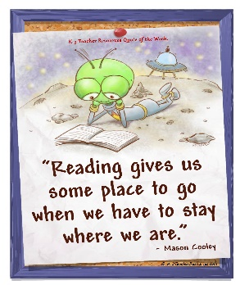
Read for AT LEAST 10 minutes every day.
I know you can do it as we would normally do a lot more when we are at school.
I would love you all to use BugClub everyday as the Bug questions teach important reading skills that we would normally be covering in lessons. Every day, I will check to see who has read and how you have got on with the questions.
If you would prefer not to use a screen to read all of the time, it is absolutely fine to read books you have at home.
Reading every day is the most important thing to do.

Phonics and Tricky ‘red’ Words
Each day, I will be giving you a sound to practice or recap. It will have the rhyme that we use to help us to learn it and some real words that contain the special friend. Have a go at reading the words and writing them making sure you use your ‘Fred Fingers’ to help you. There will also be some nonsense words to go with each sound for you to practice reading.
This week’s ‘red’ words:
I
the
you
your
said
was
are

Each week, there will be 7 ‘red’ words for you to practise to read and spell. These will be words we have looked at before so have a go at reading them and writing them, as a list and in a sentence – I was in the pool. You are the best! “Get your bag” said Mum. Are you sad? Remember capital letters, finger spaces and full stops/question marks/exclamation marks!

English
This week we are starting something different for our English learning. We are going to be looking at a story about Anansi and Tiger. These lessons are set out in the same way we would teach them in school.

Before you watch the video: Use your story map to retell the story of Anansi and Tiger. Think about what you need to remember when writing a sentence. Have you had a guess about how big of an orb web can a Darwin Bark spider make?

Watch this video for today’s lesson- https://classroom.thenational.academy/lessons/to-use-the-conjunction-and-to-join-clauses-chjk6t?activity=video&step=1

The video is 24 minutes long. It could be broken into 4 parts. Here are my suggestions:
- Up to 7:50 – You will sing the chorus from the song you learnt in yesterday’s lesson and learn verses 1 and 2 about Tiger and Queen Bee.
- Up to 11:35 – You will learn about how to use the conjunction ‘and’. This will help you to add extra detail and improve your sentences. Have a go at joining the two short sentences together to make a longer one with ‘and’.
- Up to 18:50 – Shared writing. Writing action sentences from the story using the conjunction ‘and’.
- Up to the end of the video – Independent writing – add new information to sentences using the conjunction ‘and’.
Fun spider fact at the end – can you guess how big a Goliath bird eater spider can grow to?

Activity: Write your own sentences using the conjunction ‘and’.
Have a go at finishing the sentence below thinking about what happens in the story. Remember to make the action clear! Try and create a sentence of your own. Use the song and your story map to help you.

Anansi went to the Python and _______________________.

____________________ and _______________________.

Science -
Today we are going to be looking at seasons and change.

In this lesson, we are going to be learning about the four seasons and the weather. We are going to learn what a scientist is and how important they are. We are going to complete an observation of the weather outside of our windows and compare this to the four seasons. Lastly, we will be identifying the different weather in the four seasons.

There is also a quiz to after the lesson to test your knowledge!

You will need a pen and some paper to complete the activities.

Here is the link to the video for you to watch: https://classroom.thenational.academy/lessons/what-do-we-know-about-the-weather-6ct30c?activity=video&step=1

Mums and Dads – The video is quite long but can be taught as 3 parts. Here are my suggestions:

First part – Up to 10:11 – We are scientists! Draw a picture of what you think a scientist looks like. Then you will look at different types of weather. Activity – look out of your window and draw the weather you can see. Challenge – can you label what you have drawn?
Second Part – Up to 14:55 – Write a sentence about your picture using the words below to help you.

Today the weather is _______________________ and _________________________.

You will find out what a weather forecast is and how to use a thermometer.
Third part – Up to the end of the video – Look at the 4 seasons – can you remember what they are?
Don’t worry about writing the features for each season – talk about the pictures and discuss what season it is and what features they can see. Activity – Draw 4 pictures to show the different seasons. You can do this any way you like – you can draw them, paint them, use your tablet or iPad or collage them.

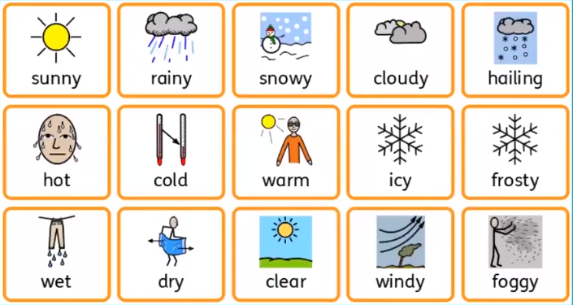

I hope you have another fantastic day of learning. Do email me if there is anything I can help you with or if you have any questions. I look forward to seeing some more of your amazing learning throughout the day. Don’t forget our catch up zoom session tomorrow at 11.30. We will be having a scavenger hunt linked to this week’s rainbow wheel challenge. You will also find out who the Learner of the week is – it could be you!

