
Monday 1st March 2021

Good morning Lime Class!
I hope you have all had a nice weekend. It’s not long now until we are all back together in class!

I am looking forward to our ZOOM session tomorrow at 11.30 where we can have a quick catch up and continue with our new topic learning. Try to have any work you have done nearby so that we can share each other’s learning. But most importantly I want to see you!

Please find your learning for today below.

If you have any issues, please do let me know as I am very happy to help in any way I can.
Please stay in close contact and email your learning each day to limeteacher@west-malling.kent.sch.uk
I would also love to hear about any other news or show and tell you have to share. So please send me an email and let me know if you would like your news shared with your friends on the class webpage.
Maths
This week we are continuing our unit on Length and Height.
Today we are Introducing the ruler.

Watch this video: https://vimeo.com/510394004

The video will ask you what can we use to measure? Think about the work you did in Maths last week. What else can we use? You will then find out why we use a ruler to measure. Do you have a ruler at home you can use? What is the same/different about your ruler and the one on the screen? Don’t worry if you don’t – do you have a tape measure or measuring tape you could use instead? You will be shown how to use a ruler to measure. Then have a go at using it to measure your crayons and a pencil. Can you start at different points when you are measuring?

Now complete the mathletics tasks I have set you on Making Teen Numbers.

There are no written activities for you today as I would like you to do the activities from the video. If you want to continue your learning on measuring, have a go at finding some other objects in your house and putting them in order of length. How do you know which is the longest/longer or shortest/shorter?
Reading
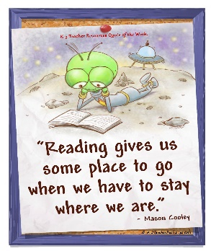
Read for AT LEAST 10 minutes every day.
I know you can do it as we would normally do a lot more when we are at school.
I would love you all to use BugClub everyday as the Bug questions teach important reading skills that we would normally be covering in lessons. Every day, I will check to see who has read and how you have got on with the questions.
If you would prefer not to use a screen to read all of the time, it is absolutely fine to read books you have at home.
Reading every day is the most important thing to do.
Phonics and Tricky ‘red’ Words
Each day, I will be giving you a sound to practice or recap. It will have the rhyme that we use to help us to learn it and some real words that contain the special friend. Have a go at reading the words and writing them making sure you use your ‘Fred Fingers’ to help you. There will also be some nonsense words to go with each sound for you to practice reading.
This week’s ‘red’ words:
of
want
what
they
to
he
me
Each week, there will be 7 ‘red’ words for you to practise to read and spell. These will be words we have looked at before so have a go at reading them and writing them, as a list and in a sentence – What do you want? They are at the zoo. He is my dad! Remember capital letters, finger spaces and full stops/question marks/exclamation marks!
English
This week we are continuing with our story about Anansi and Tiger. These lessons are set out in the same way we would teach them in school.

Before you watch the video: Have your story map from last week with you as it will help you with the activity for today. Did you guess how long a diving bell spider can stay under water for?

Watch this video for today’s lesson- https://classroom.thenational.academy/lessons/to-box-up-for-purpose-6th3ac?step=1&activity=video

The video is 26 minutes long. It could be broken into 3 parts. Here are my suggestions:
- Up to 12:34 – You will do a movement activity – copy and follow the actions from the story. Then you will look at using the special friend ‘nk’. Fred/robot talk the words then have a go at reading the words. Don’t worry too much about writing the words!
- Up to 17:03 – Use your story map or the one on the screen to retell the story of Anansi and Tiger.
- Up to the end of the video – Box up the story. You will do this together first and then have a go at your own one.
Fun spider fact at the end – can you guess how long spiders have been in the world?

Activity: Boxing up the story.
You can use the template below or create your own one. Have a go at drawing a simple picture of the important parts of the story and some notes/keywords to remind you what happens.
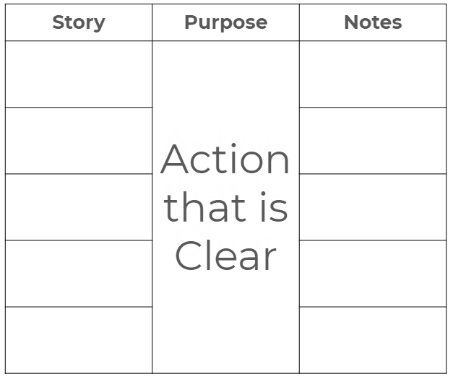

I hope you have a fantastic first day back of learning. Remember, we will have a zoom session tomorrow at 11.30am. Do email me if there is anything I can help you with or if you have any questions.

