
Tuesday 2nd March 2021

Good morning Lime Class!

am really looking forward to our get together over ZOOM for a catch up and a quick History lesson to continue our new topic today at 11.30am. Try to have any work you have done nearby so that we can share each other’s learning. But most importantly I want to see you!
Please find your learning for today below.

If you have any issues, please do let me know as I am very happy to help in any way I can.
Please stay in close contact and email your learning each day to limeteacher@west-malling.kent.sch.uk
I would also love to hear about any other news or show and tell you have to share. So please send me an email today and let me know if you would like your news shared with your friends on the class webpage.

Maths
This week we are continuing our unit on Length and Height.
Today we are Measuring length.

Watch this video: https://vimeo.com/510394371

In this video you will be using the rulers on the screen to measure and compare the lengths of objects. Where do you need to place the object you are measuring? Where do you start measuring from on the ruler? It will move on to looking at blocks and rulers and asking you which is longer? How do you know which tower is longer? Pause the video to complete questions 1 and 2 then 3 on the worksheet. Final challenge – How could you make the 2 towers the same length?

Now complete the mathletics tasks I have set you on Subtracting from 20.

The worksheet for today is the one that goes with the video. Use the rulers and blocks on the sheet to measure the length of the objects and towers.

Reading
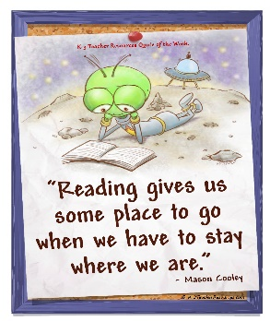
Read for AT LEAST 10 minutes every day.
I know you can do it as we would normally do a lot more when we are at school.
I would love you all to use BugClub everyday as the Bug questions teach important reading skills that we would normally be covering in lessons. Every day, I will check to see who has read and how you have got on with the questions.
If you would prefer not to use a screen to read all of the time, it is absolutely fine to read books you have at home.
Reading every day is the most important thing to do.

Phonics and Tricky ‘red’ Words
Each day, I will be giving you a sound to practice or recap. It will have the rhyme that we use to help us to learn it and some real words that contain the special friend. Have a go at reading the words and writing them making sure you use your ‘Fred Fingers’ to help you. There will also be some nonsense words to go with each sound for you to practice reading.
This week’s ‘red’ words:
of
want
what
they
to
he
me
Each week, there will be 7 ‘red’ words for you to practise to read and spell. These will be words we have looked at before so have a go at reading them and writing them, as a list and in a sentence – What do you want? They are at the zoo. He is my dad! Remember capital letters, finger spaces and full stops/question marks/exclamation marks!
English
This week we are continuing with our story about Anansi and Tiger. These lessons are set out in the same way we would teach them in school.

Before you watch the video: Did you guess how long spiders have been in the world?

Watch this video for today’s lesson- https://classroom.thenational.academy/lessons/to-explore-how-writers-create-clear-action-ctgk8c?step=1&activity=video

The video is 23 minutes long. It could be broken into 3 parts. Here are my suggestions:
- Up to 6:17 – You will learn the last 2 verses to the song about the Python and the ending of the story.
- Up to 15:16 – Read as a write. Follow along and listen to the story. (Below). You will then use the writing toolkit to find the key parts in that part of the story – actions, where and when and the adjectives (describing words). It will move on to verbs – doing words. Spot the verbs in the sentences,
- Up to the end of the video – Shared writing – think of powerful verbs to go with each animal from the story.
Fun spider fact at the end – can you guess how many times a spider moults in its life?

Activity: Writing verbs.
Write a verb that describes a key action for each of the 4 characters – Anansi, Tiger, Queen Bee and Python. Remember that a verb is a doing word – jump, run, called, flew.
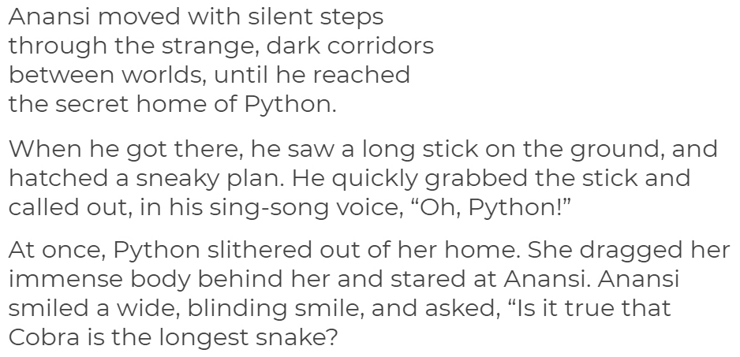

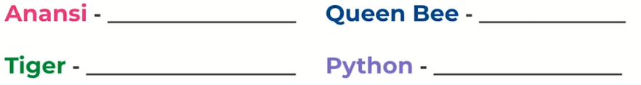

I hope you have another fantastic day of learning. Remember, we will have a zoom meeting today at 11.30am. I am looking forward to seeing you all and sharing our learning. I will also be doing a quick history lesson which will help you complete an activity afterwards.

