
Wednesday 3rd March 2021

Good morning Lime Class!

It was lovely seeing so many of you on our Zoom session yesterday! I hope you all enjoyed seeing each other and joining in with some of our learning, just like we would in class.

Please find your learning for today below.
If you have any issues, please do let me know as I am very happy to help in any way I can.
Please stay in close contact and email your learning each day to limeteacher@west-malling.kent.sch.uk
I would also love to hear about any other news or show and tell you have to share. So please send me an email today and let me know if you would like your news shared with your friends on the class webpage.
Maths
This week we are continuing our unit on Length and Height.
Today we are Adding length problems.

Watch this video: https://vimeo.com/511039862

The video will ask you to use the ruler and objects on the screen to find out how long more of each object would be. You will need to use your adding skills to add 2 amounts together. It will then move on to adding lengths of objects to find what the total length is. Use the measurements to work out which group of objects is longer. Think about how you are going to work out the answers – are you going to use counters or objects, will you draw it or will you count on?

Now complete the mathletics tasks I have set you on Related facts.

The work sheet today is the one that goes with the video. You don’t need to print the worksheet and can write the answers on a piece of paper. Have a go at writing the addition number sentence that you worked out for each answer.

Reading
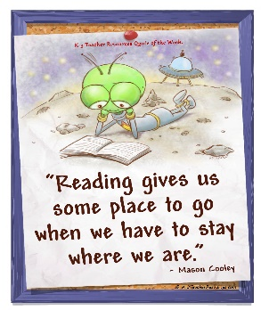
Read for AT LEAST 10 minutes every day.
I know you can do it as we would normally do a lot more when we are at school.
I would love you all to use BugClub everyday as the Bug questions teach important reading skills that we would normally be covering in lessons. Every day, I will check to see who has read and how you have got on with the questions.
If you would prefer not to use a screen to read all of the time, it is absolutely fine to read books you have at home.
Reading every day is the most important thing to do.

Phonics and Tricky ‘red’ Words
Each day, I will be giving you a sound to practice or recap. It will have the rhyme that we use to help us to learn it and some real words that contain the special friend. Have a go at reading the words and writing them making sure you use your ‘Fred Fingers’ to help you. There will also be some nonsense words to go with each sound for you to practice reading.
This week’s ‘red’ words:
of
want
what
they
to
he
me

Each week, there will be 7 ‘red’ words for you to practise to read and spell. These will be words we have looked at before so have a go at reading them and writing them, as a list and in a sentence – What do you want? They are at the zoo. He is my dad! Remember capital letters, finger spaces and full stops/question marks/exclamation marks!

English
This week we are continuing with our story about Anansi and Tiger. These lessons are set out in the same way we would teach them in school.

Before you watch the video: Did you guess how many times a spider moults? You will need your boxing up from Monday and your action verbs from yesterday’s lesson to help plan your writing.

Watch this video for today’s lesson- https://classroom.thenational.academy/lessons/to-write-clear-action-part-1-64tp6r?activity=video&step=1

The video is 26 minutes long. It could be broken into 3 parts. Here are my suggestions:
- Up to 8:12 – You will do a speaking activity to help put actions into a clear order. Can you put the sentences from the story into the correct order? Then you will read words on the screen with the special friend ‘nk’. Are they real or an alien word?
- Up to 19:11 – Shared writing to make sure your action is really clear. Use your action verbs to help you. Then it is your turn to write. (See activity below).
- Up to the end of the video – Editing your sentences – check that your action is clear. Swap, add and delete words to make your writing even better. 5 finger check – capital letter, finger spaces, spellings, full stop and makes sense.
Fun spider fact at the end – how small is the smallest spider in the world?

Activity: Write clear action for the first part of the story.
Write the action scene at the beginning of the story between Anansi and Tiger. Use the example below to help you. Then have a go at editing your work. Are there any words you could swap or add in to make your writing even better?

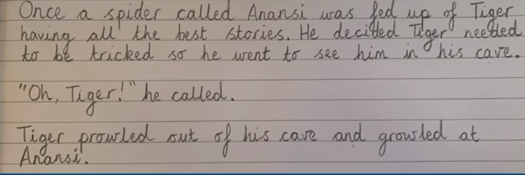

I hope you have another fantastic day of learning. Do email me if there is anything I can help you with or if you have any questions.

