  Reading in unusual places Take a photo of yourself reading in the most unusual or creative place you can! | Reading Out Loud  Video yourself reading your favourite short story/clip of your favourite story and email it to your teacher. | Dressing up!  Dress up as a book character – you must use items you can find around your home. Take a photo and email it to your teacher so it can be uploaded to the website for your friends to guess who you are.
Story Prediction    Pobble 365 Image – what do you think might happen in this story?  The Golden Key | Guess who  Write and share a series of clues about a character from a book. Can someone at home or school guess who it is? | Instructions    Read a set of instructions to bake or cook something delicious!
Potato Character  Use a potato to design and make your own character! Write a short description about them. It can be a familiar character or one you’ve made up yourself! | World Book Day Live  Join a World Book Day LIVE event on the 4th March.  World Book Day Live | Bedtime Story  Snuggle down in your PJs and enjoy a bedtime story with your family.
Word Hunt  Go on a word hunt    On your daily exercise, how many words can you spot and write down on you walk? | Joke Time!  Read a joke to share with your friends! Who can find the funniest one? Share it with your teachers and the best ones will be added to the web page (it’s got to be funny!). | Book Mark  Create a new book mark for yourself or somebody else to use.  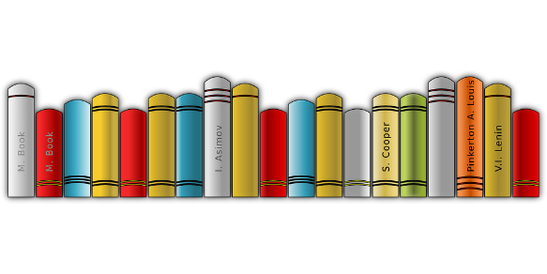
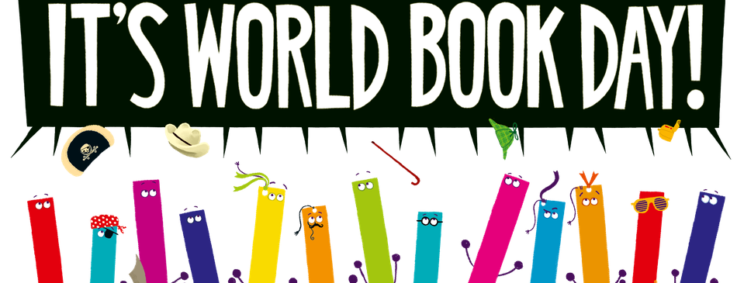
Email pictures of you completing each challenge so we can add them to each class page.

Complete all of the reading challenges to be in with the chance to win a book-tastic prize!

