Draw some fish in the net.
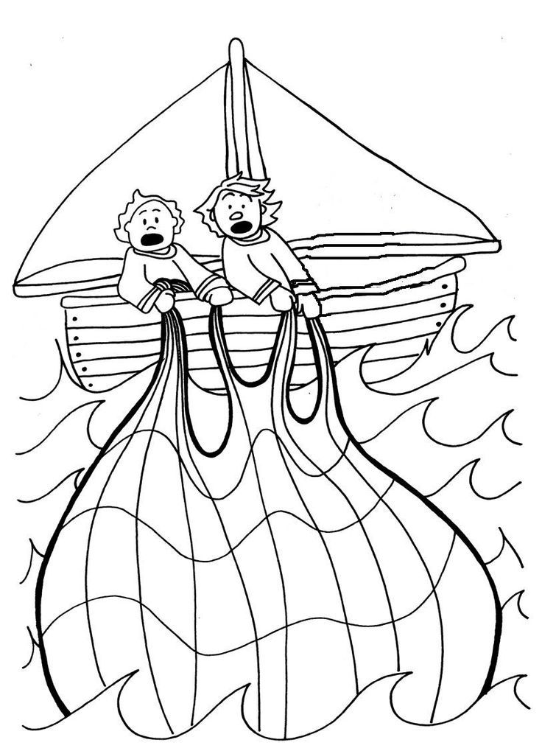
Jesus said, ‘Put your nets in the water, you will catch some fish’.
He said to his friends ‘You will be fishers of men’.

Christians believe Jesus had a message of friendship.

