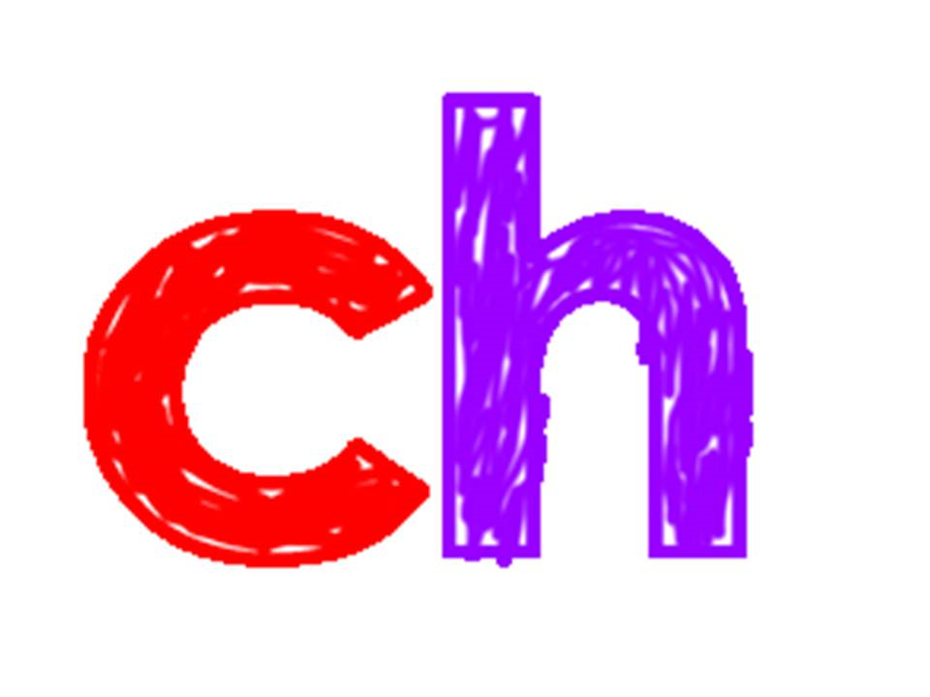
Sort the pictures into two groups, ‘sh’ and ‘ch’.
You could practise your cutting and cut them out!


