Home Learning tasks: Week beginning 18th January
For Maths, this week we are using some of the videos on the Oak National Academy Website. https://classroom.thenational.academy/subjects-by-key-stage/early-years-foundation-stage/subjects/maths Please click on ‘numbers within 10’ for Monday, Tuesday and Thursday.
Each lesson has a video and a follow up activity to print. We have suggested a practical alternative on the planning grid, please choose which activity you wish to do.
If you wish to print the activity, click on the lesson and then press the next button until you reach the slide which says ‘worksheet’. There is then a download button at the top which says ‘worksheet.’

Mathletics – Tasks will be added at the beginning of the week for you to do in your own time.

Bug club: We hope you are enjoying reading some of the books. We will keep an eye on your ‘book library’ but please do let us know if you have no books left.
We continue with our Power of Reading sessions and this week our story focus ‘No Dinner’ fits in with our topic ‘India’. These sessions combine our topic, communication & Language and reading skills. We would normally do this session at 1pm in school. You may like to fit this in at the same time on your timetable. We will upload the document which includes pictures and key questions on a Monday. On the planning grid below, we have outlined which section to complete each day. You do not need the book to complete the activities. There will be a story time video uploaded to Tapestry sharing the story.

We will share our learner of the week again in our Friday zoom session

Email: chestnutteacher@west-malling.kent.sch.uk
 | Reading/Phonics:  All activities relate to the sound of the week ‘ng’. | 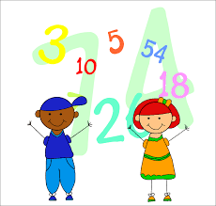  Mathematics  Numbers within 10 | 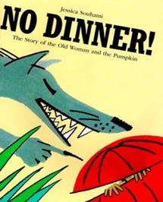  Understanding of the world/ Communication &  Language/Power of Reading: | Story time!
Monday  Hopscotch phonics! | Please watch RWI video introducing new sound ‘ng’. This sound comes at the ends of words as in ‘sing’  https://www.youtube.com/watch?v=Vu2jBrMgX3M  Independent activity – Hop scotch!  Using a cereal box or other cardboard packaging, cut out six squares. Write on the squares the sounds ‘sh, ch, ng’ and three other sounds of your choice. Throw a button, a dice or a lego brick on the hopscotch. Say the sound it lands on!  You may like to watch an episode on Alphablocks:  Series 3 Episode 11: Champ (as a recap of sh and ch). | Numbers to 10:  Oak Academy –  Lesson 4 ‘Counting up to 9 objects reliably’  Practical activity:  Draw 10 squares on a piece of paper to make a ten frame. Using digit cards 1-10 (made last week), turn one over and count objects into the ten frame. | Power of Reading:  Complete session one ‘Explore it’.  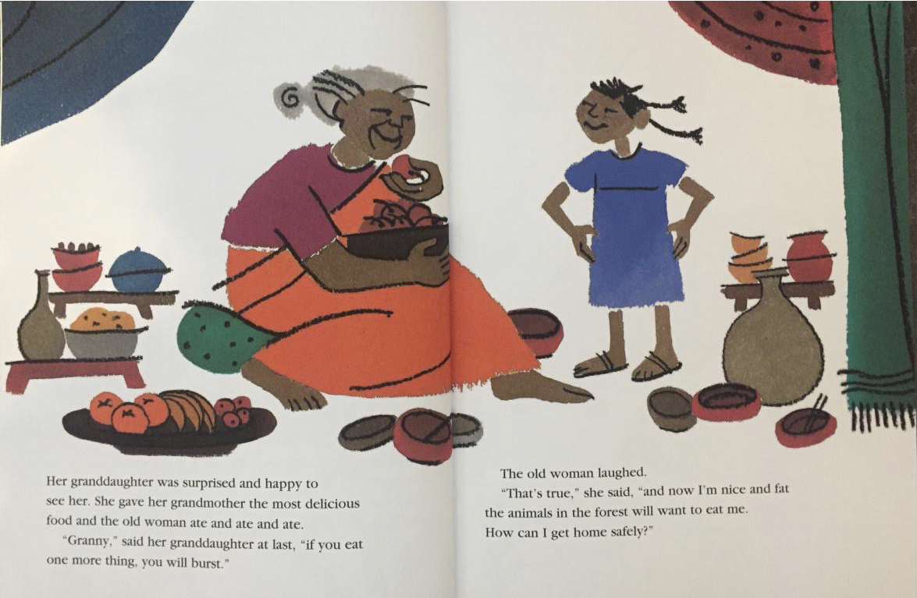  Look at the picture, talk about it and answer the questions. | RE:  PowerPoint by Mrs Penfold.*
Tuesday  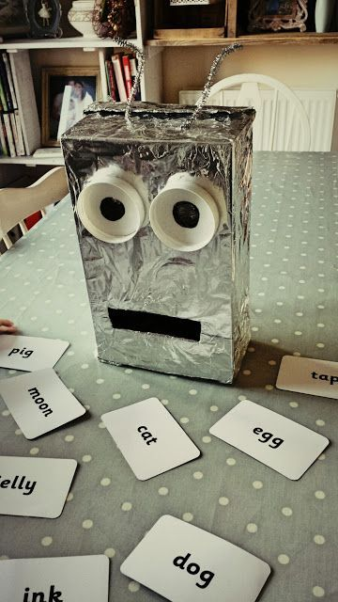  Blending robot! | -Join in with our sounds recap video.  -Watch PowerPoint ‘Oral blending’, point to the correct picture.  -We would like you to make a blending robot like ‘Robbie’ in class. (See photo for idea) Use picture/word cards provided or write the words. Say the sounds (s-i-ng). Ask your child to repeat the sounds and push the sounds together. When they say the word, they can feed it to the robot! | Numbers to 1  Oak Academy-  Lesson 5 ‘Counting up to 10 objects reliably’  Practical activity: Turn over one of your digit cards 1-10, write it down then draw/paint spots to match. Repeat. | Power of Reading:  Complete session two ‘Illustrate it’.  Look at the feast in the picture. Answer the questions about the food. Draw or paint your favourite food.
Wednesday | Reading challenge: Today we would like you to make a blending word wheel! You will need some card and a split pin if possible. (See example below). Turn the wheel and blend the sounds to read the word. | Numbers to 10  Watch video with Mrs Penfold – (Tapestry)  Practical activity:  Put your digit cards in a line. Close your eyes, ask a grown up to take one away, which one is missing? Count on from 1 to find the answer! | Power of Reading:  Complete session three ‘Talk about it’.  Answer the questions. Do you have any questions of your own? | Zoom live 2:30 with Mrs Penfold!  PSHE  ‘Our Feelings’
Thursday | Writing: Watch Video with Miss Penighetti (Tapestry)  Complete ‘Tap, build it, write it’ activity.  You can choose which words/pictures to do.  fan tin  web wing  mop ship  jug chop  You may like to reuse the sheet by writing the words on a separate piece of paper.  If you are unable to print, draw 3 dots on a piece of paper for your child to have a go at ‘tapping’ the three sounds. Also, encouraging them to tap each finger as they say each sound. | Number to 10  Please watch lesson 8 ‘Placing numbers within ten in order’ and complete activity.  Practical activity:  Order your set of digit cards. Use buttons, Lego or sweets, to count out and match to each number. What do you notice? | Power of Reading:  Complete session four ‘Imagine it’.  Imagine what food might have been in the empty bowls. | Story time Video with Mrs Penfold (on Tapestry)  ‘No Dinner’ by Jessica Souhami.
Friday | Please take this day to practice sounds, key words and reading. | Numbers to 10  Watch Powerpoint with Miss Penighetti.  Practical activity:  Can you make ten in lots of different ways? There are some ideas on the end of the PowerPoint. | Power of Reading:  Complete session five ‘‘Create it’.  Plan and create a special dish to share as a family. | Zoom live 2:30 with Miss Penighetti!  Show and tell about India or anything at all!

*Please note, all videos and PowerPoints will be uploaded to the website by 9am on the day. We will upload any worksheets on Sunday evening so if you wish you can print in advance. They will also be uploaded on the day for easy access.

