Home Learning tasks: Week beginning 1st February.
For Maths, this week we are using a mixture of videos from the Oak National Academy Website and The White Rose.
For Monday and Tuesday please use Session 3 and 4 on White Rose and Session 5 for Friday in Growing 6,7,8 – Week 2 https://whiterosemaths.com/homelearning/early-years/growing-6-7-8-week-2/
Please click on ‘addition within 6’ on Oak Academy for Wednesday and Thursday. https://classroom.thenational.academy/subjects-by-key-stage/early-years-foundation-stage/subjects/maths
Each lesson has a video and a follow up activity to print. We have suggested a practical alternative on the planning grid, please choose which activity you wish to do. If you wish to print the activity, click on the lesson and then press the next button until you reach the slide which says ‘worksheet’. There is then a download button at the top which says ‘worksheet.’ We have also uploaded them to the website.
Mathletics – Tasks will be added at the beginning of the week for you to do in your own time.
Bug club: We hope you are enjoying reading some of the books. We will keep an eye on your ‘book library’ but please do let us know if you have no books left. You must complete the quizzes to finish each book.
We continue with our Power of Reading sessions and this week our story focus ‘Anna Hibiscus Song’ fits in with our topic ‘Africa’. These sessions combine our topic, communication & Language and reading skills. We would normally do this session at 1pm in school. You may like to fit this in at the same time on your timetable. We will upload the document which includes pictures and key questions on a Monday. On the planning grid below, we have outlined which section to complete each day. You do not need the book to complete the activities.
We will share our learner of the week again in our Friday zoom session
Email: chestnutteacher@west-malling.kent.sch.uk
 | Reading/Phonics:  All activities relate to the sound of the week ‘th’. | 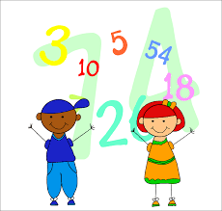  Mathematics  Addition as combining groups | 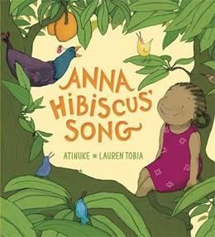  Understanding of the world/ Communication &  Language/Power of Reading: | Story time!
Monday | Please watch RWI video introducing new sound ‘th’.  https://www.youtube.com/watch?v=VoZlPKvL2ZA  Independent activity – Play the ‘roll and say’ the sound game. Attached to the website. Roll the dice, find the number on the sheet and say the sound next to it. Try to say the sound, the rhyme and show the sign for those we have done. | Combining groups  White Rose - Growing 6,7,8 Session 3 – Combining two groups using tens frame.  Practical activity: ‘Talk about the pictures’. Have a go at creating your own picture with things to add. | Power of Reading:  Complete session one ‘Explore it’.  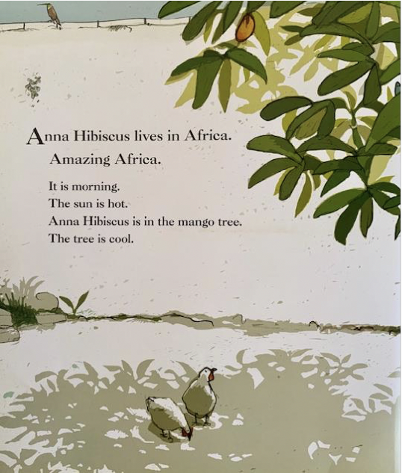  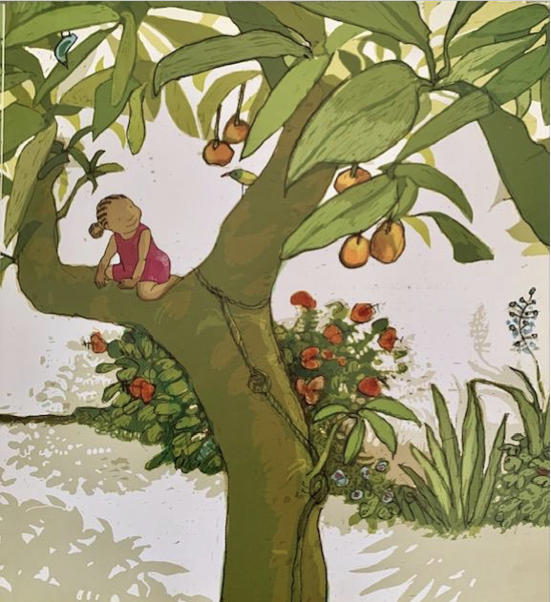  Look at the picture, talk about it and answer the questions. | RE PowerPoint with Mrs Penfold
Tuesday | Oral blending. PowerPoint with Mrs Penfold “I spy with my little eye. . .”  Independent activity: Collect six CVC objects (e.g. cat, mat, pig). Put them on a tray. Play ‘blending I spy’. I spy with my little eye a ‘c-u-p’. Take turns to so that the children get experience of guessing the words and saying the sounds in the object. You may like to use objects with our new special friends. | Combining groups  White Rose Growing 6,7,8 Session 4 – Combining two groups (dominoes)  Practical activity: If you have a set of dominoes add the spots on each side. Or you can use the resource that goes with the video. | Power of Reading:  Complete session two ‘Illustrate it’.  Talk about the birds. Can you draw the different birds?
Wednesday | Reading challenge: Today we would like you to get active in our phonics and do some bouncy blending! Using the words below, put each sound on a card. Jump saying the sounds, then push together to say the word. Remember our special friends go together on one card, one sound.  thin, thick, think, thing, moth  You may like to play the game using different words of your choice. 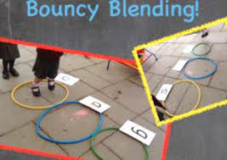 | Combining groups  Oak Academy - Addition within six ‘Combining two groups’ (Lesson 2) – adding using part/whole model  Practical activity: Turn over 2 digit cards 1-5. Use objects to combine and add the two groups together. Use the part-whole model to support. | Power of Reading:  Complete session three ‘Talk about it’.  Look at the picture, answer the questions. | Zoom live 2:30 with Mrs Penfold!
Thursday | Watch video by Miss Penighetti on Tapestry. Silly soup game.  Silly soup recording activity. | Combining groups  Oak Academy - Addition within six ‘Combining two groups with zero’ (Lesson 3) – adding using part/whole model.  Practical activity: Talk about the pictures and say the sentence stems. You do not need to print the resource. | Power of Reading:  Complete session four ‘Imagine it’.  Look at your bird drawings and think about their ‘songs’. There is a link to listen to some birdsongs. | Story time with Mrs Penfold  ‘Anna Hibiscus Song’.
Friday | Please take this day to practice sounds, key words and reading. | Combining groups  White Rose Growing 6,7,8 ‘Adding more’ Session 5  Practical activity: Play the game or you may like to play snakes and ladders using 2 dice to encourage adding the spots. | Power of Reading:  Complete session five ‘‘Create it’.  What things make you happy?  Does singing make you happy?  Can you make up a happy song? | Zoom live 2:30 with Miss Penighetti!  Please dress up in your favourite dressing up outfit!

*Please note, all videos and PowerPoints will be uploaded to the website by 9am on the day. We will upload any worksheets on Sunday evening so if you wish you can print in advance. They will also be uploaded on the day for easy access.

