RE – Monday 8th February
Cut out or match with a line the symbols to the pictures of the story. What are the messages from each story?
When you have finished talk with a grown up about the question at the bottom of this page. Grown-ups – It would be great if you could write down what they say and upload to Tapestry. Thank you!

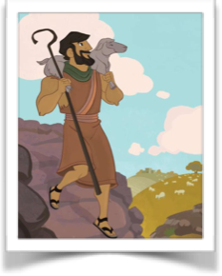 |  | 
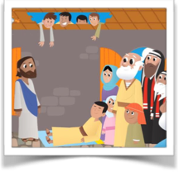 |  | 
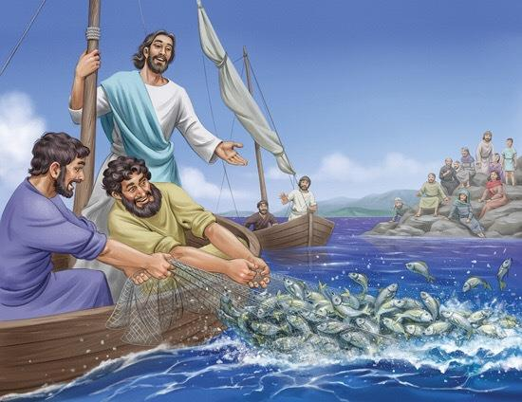 |  | 
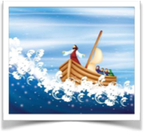 |  | 
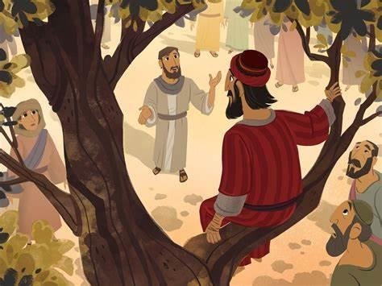 |  | 
What do Christians believe is special about Jesus about the message he brings?

