Session one: Explore it
Look at the illustration. What words or phrases can you think of to describe him? 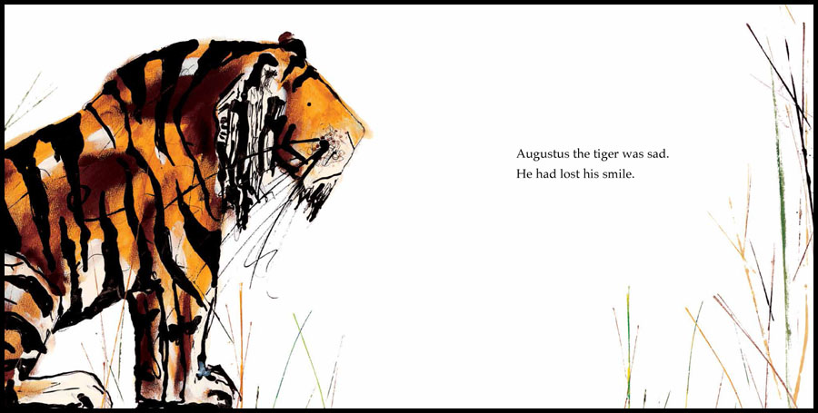
*Who is this?
*What can you say about the tiger?
*How does he feel? Why do you think that?
* What has happened?
* Does anything puzzle you?
* Does this remind you of anything in real life or in stories?

Session 2: Talk about it

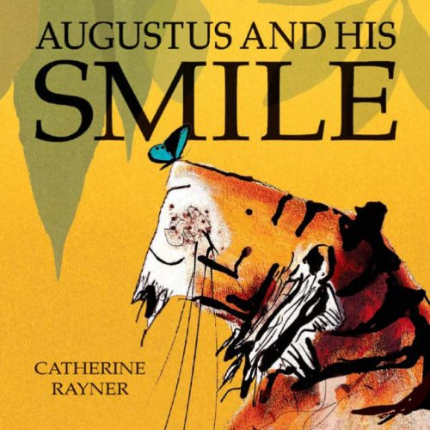
Now look at this picture and compare to the image of a glum Augustus from the first session.
*How does Augustus feel now? *How do you know?
*What can we say about him now?
* Why do you think he feels differently here?
*What might have happened?
* Think about the picture of glum Augustus, has anything ever made you feel miserable when you were feeling fine before?
*What cheers you up when you feel down in the dumps?

Session 3: Illustrate it.
Revisit the image of Augustus on the front cover with the butterfly on his nose.
Imagine being either the tiger or the butterfly. What might have happened just before this? What is going to happen next? What are they saying to each other? What are they thinking?
Draw a picture of Augustus and the butterfly. You may like to add your own speech bubbles to show what the tiger or the butterfly is saying.

Session 4: Imagine it.
Look at the first part of the story:
‘Augustus the tiger was sad. He had lost his smile. So he did a HUGE tigery stretch and set off to find it.’
*Where might he go to find his smile?
*Where do tigers live?
*Who might he meet there?
*What do tigers like to do?
You may like to research about real tigers or draw pictures which show where Augustus might have looked for his smile.
Below is are some links you may like to watch about tigers.
https://kids.nationalgeographic.com/videos/amazing-animals/#/202850883789
https://www.bbc.co.uk/iplayer/episode/b01klvrc/andys-wild-adventures-series-2-4-tigers
http://www.bbc.co.uk/newsround/22831701

Session 5: Create it.
You may choose one of the two options.
1. If you did some research about tigers you may like to create an Information poster about tigers. You could show where they live, what they like to eat,
2. Or you could think a little more about where the tiger found his smile and use your pictures to help you orally tell your own version of the story.

