th |   This Photo by Unknown Author is licensed under CC BY-NC | sh |   This Photo by Unknown Author is licensed under CC BY-SA
ng |   This Photo by Unknown Author is licensed under CC BY-SA | nk | 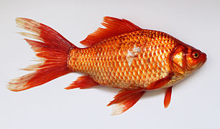
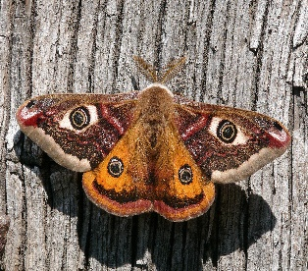  This Photo by Unknown Author is licensed under CC BY-SA | sh |   This Photo by Unknown Author is licensed under CC BY-NC | qu
ch | 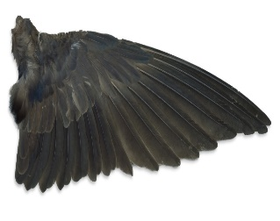 |   This Photo by Unknown Author is licensed under CC BY-SA | th

Three in a row
- Each choose some coloured counters/Lego bricks/buttons
- Take it in turns to choose a square. Either say the special friend sound or the special friend sound within the picture.
- If you get it right, place one of your counters on that square.
- The first person to get three of their counters in a row wins.

