Home Learning tasks: Week beginning 8th February.
For Maths, this week we are using a mixture of videos from the Oak National Academy Website and The White Rose.
For Monday and Tuesday please White Rose, use Session 4 and 5 in ‘It’s me 1,2,3’ – Week 3 https://whiterosemaths.com/homelearning/early-years/its-me-1-2-3-week-3/
For Wednesday please use Oak National Academy, ‘shape and sorting’ - Lesson 4 https://classroom.thenational.academy/subjects-by-key-stage/early-years-foundation-stage/subjects/maths
Each lesson has a video and a follow up activity to print. We have suggested a practical alternative on the planning grid, please choose which activity you wish to do. If you wish to print the activity, click on the lesson and then press the next button until you reach the slide which says ‘worksheet’. There is then a download button at the top which says ‘worksheet.’ They are also attached to the website.
Mathletics – Tasks will be added at the beginning of the week for you to do in your own time.
Bug club: We hope you are enjoying reading some of the books. We will keep an eye on your ‘book library’ but please do let us know if you have no books left. You must complete the quizzes to finish each book.
We continue with our Power of Reading sessions and this week our story focus ‘Augustus and his smile’ fits in with our topic ‘China’. These sessions combine our topic, communication & Language and reading skills. We would normally do this session at 1pm in school. You may like to fit this in at the same time on your timetable. We will upload the document which includes pictures and key questions on a Monday. On the planning grid below, we have outlined which section to complete each day. You do not need the book to complete the activities.
We will share our learner of the week again in our Friday zoom session
Email: chestnutteacher@west-malling.kent.sch.uk
 | Reading/Phonics:  This week the activities are recapping some of our sounds learnt so far. | 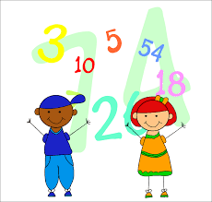  Mathematics  Positional and directional language | 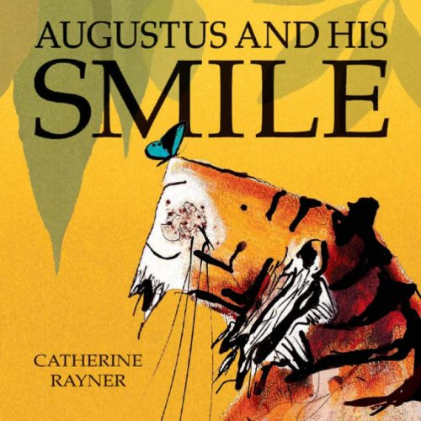  Understanding of the world/ Communication &  Language/Power of Reading: | Story time!
Monday  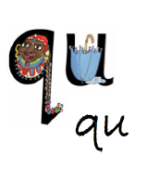 | Please watch RWI video introducing new sound ‘qu’.  https://www.youtube.com/watch?v=SjlFid_HufQ  Independent activity – Play ‘Three in a row’ attached to the webpage.  If you can’t print you may like to set up your own game using your letter cards and objects. | Positional language  White Rose – ‘It’s me 1,2,3’ Week 3 Session 4.  Practical activity: Play hide and seek with your teddy as described in the video. Use the following words to describe where he is: under, on, in, behind, next to, over, between | Power of Reading:  Complete session one ‘Explore it’.  Look at the picture, talk about it and answer the questions.   | RE PowerPoint with Mrs Penfold
Tuesday | Oral blending. Watch the video by Mrs Penfold  Using the pictures in the PowerPoint attached say the sounds in the wrong order for your child. Can they put them in the right order? You may like to use real objects so the children aren’t looking at the screen. | Positional language  White Rose ‘It’s me 1,2,3’ Week 3 Session 5.  Practical activity: Build your own obstacle course. Can you include things where you have to go ‘under’, ‘over’, ‘around’, ‘in’, ‘through’? | Power of Reading:  Complete session two ‘‘Talk about it’.  Talk about the front cover and compare to the first illustration from session 1.
Wednesday   | Reading challenge: Today we would like you to see if you can ‘crack the code’ and read the secret word!  The code cracker sheet is uploaded to the webpage. If you are unable to print you can just record the answers on a piece of paper or build the word with your letters. Good luck! | Positional language  Oak Academy – Shape and sorting ‘Using mathematical language to describe position accurately’ (Lesson 4)  Practical activity:  Use some of your toys to set up a scene. Describe where each object is.  Play ‘Simon says’ for example ‘Simon says put your hands above your head’ | Power of Reading:  Complete session three ‘Illustrate it’.  Look at the picture, answer the questions. Draw your own picture with speech bubbles. | Zoom live 2:30 with Mrs Penfold!  ‘Wacky Wednesday!’ – Please bring a smile and a joke to share!
Thursday | Watch the PowerPoint ‘Toy Shop’ by Miss Penighetti  Play your own Toy shop phonics! | Directional/positional language  Watch the video by Miss Penighetti  Practical activity: If the weather is good go for a walk in your local area. Talk about the direction you are taking. Forwards, do you have to turn? Which way?  Or you could play robots. You are a robot and your adult has to give you instructions such as: move 5 steps forwards, turn left, take 3 steps backwards.  You may like to sing the ‘Hokey cokey’ song and talk about each directional movement you are completing. | Power of Reading:  Complete session four ‘Imagine it’.  Answer the questions about the text from the book.
Friday | Please take this day to practice sounds, key words and reading. | Directional/positional language  Watch the PowerPoint by Miss Penighetti  Practical activity: Ask your adult to hide some treasure and then give you instruction to find it. You can then swap roles and give your adult instructions to find the hidden treasure. Remember to use the language: forwards, backwards, left, right, turn. | Power of Reading:  Complete session five ‘‘Create it’.  Make an information poster or orally tell your own story. | Zoom live 2:30 with Miss Penighetti!  Story time with Mrs Penfold – please watch after Power of Reading activities.

*Please note, all videos and PowerPoints will be uploaded to the website by 9am on the day. We will upload any worksheets on Sunday evening so if you wish you can print in advance. They will also be uploaded on the day for easy access.

