Home Learning tasks: Week beginning 22nd February.

Superheroes!


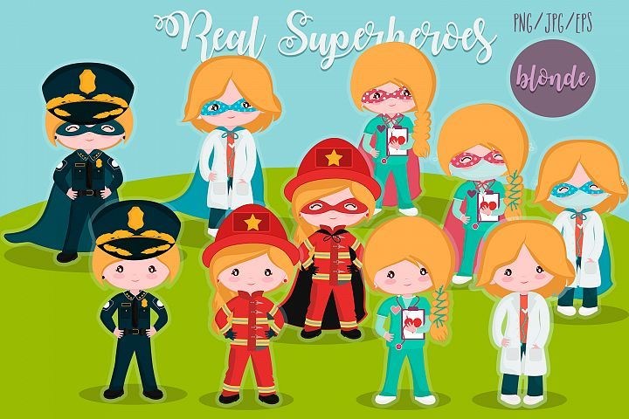
Normally in school the children would be involved in choosing our new topic. As this was not possible we have chosen the topic ‘Superheroes’. We will start by exploring superheroes they may be familiar with, then move onto exploring real superheroes, hopefully when we are back in school. For the first two weeks, we will explore our topic through a question for the children to investigate rather than a power point. Practical ideas will be uploaded to the website on a Friday. We hope you will agree this approach for this topic, initially, will suit you child and encourage their interest and curiosity in a more relevant way. Our Power of Reading stories will loosely link, although not directly. Through our stories, we will explore different feelings and link this to the feelings of superheroes. Our first Power of Reading book explores the feelings of being brave. Please do talk with your children about what that means, when they have been brave and how superheroes are brave.

Mathletics – Tasks will be added at the beginning of the week for you to do in your own time.
Bug club: We hope you are enjoying reading some of the books. We will keep an eye on your ‘book library’ but please do let us know if you have no books left. You must complete the quizzes to finish each book.

We will share our learner of the week again in our Friday zoom session

Email: chestnutteacher@west-malling.kent.sch.uk

Power of Reading
We continue with our Power of Reading sessions and this week our story focus is ‘The Brave Bear’. These sessions combine our topic, communication & Language and reading skills. We would normally do this session at 1pm in school. You may like to fit this in at the same time on your timetable. We will upload the document which includes pictures and key questions on a Monday. On the planning grid below, we have outlined which section to complete each day. You do not need the book to complete the activities.

Phonics –
We have now completed all the sounds in speed set 1 and move to speed sound Set 2 of Read Write Inc. If you feel your child needs to revisit some of the sounds in speed set 1 there are scheduled Read, Write Inc programs running daily at 9:30am. Search Read, Write, Inc Daily Phonics lessons. The sounds that will be aired in the first two weeks back are: -

22nd Feb – ‘ng’ 1st March – ‘d’
23rd Feb – ‘nk’ 2nd March – ‘t’
24th Feb – ‘m’ 3rd March – ‘i’
25th Feb – ‘a’ 4th March – ‘n’
26th Feb – ‘s’ 5th March – ‘p’

We are very much hoping that we will be back in school, if not we will let you know further information on these daily sessions nearer the time.

Maths – Pattern
For Maths the next two weeks, we are exploring pattern. We have done a little bit in school on pattern just before Christmas and have explored Christmas patterns such as those on wrapping paper, candy canes or jumpers. Pattern is a very practical focus and in school we would explore pattern in lots of ways. Therefore, there may not be a ‘video’ session for each day to allow children time to explore. Also, we are happy if you wish to explore pattern completely practically and leave all the video sessions. The focus this week is to:
1: Explore and find patterns (spotty/stripy/repeating)
2. Copy a repeating pattern (e.g. red/blue/red/blue)
3. Continue a repeating pattern
4. Create a repeating pattern.
If you wish to use the videos, please use Oak National Academy – Pattern and early Number on Tuesday
https://classroom.thenational.academy/units/pattern-and-early-number-187a
and White Rose on Wednesday and Thursday - ‘Just like me’ - week 3
https://whiterosemaths.com/homelearning/early-years/week-3/

There is nothing to print this week for the maths as it is all practical.
Please do take photos of your learning and upload to Tapestry.

 | Reading/Phonics:    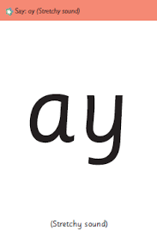  ay  may I play? | 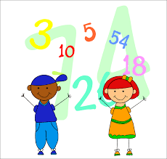  Mathematics  Pattern | Communication & Language/Power of Reading: | Story time!
Monday  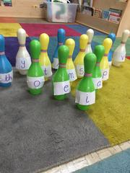  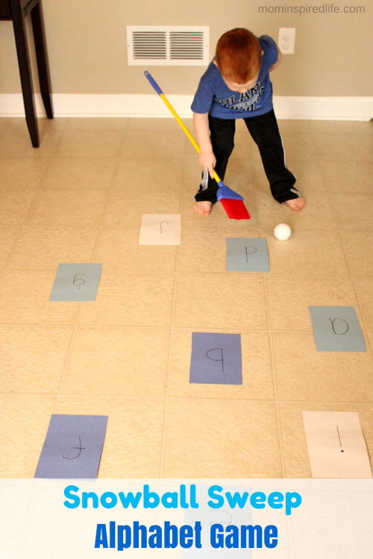 | Please watch RWI video introducing new sound ‘ay’.  https://www.youtube.com/watch?v=3NL9uIOIpq0  Independent activity – Write the sounds ‘nk, ng, sh, ch, qu, th, ay’ on separate pieces of paper and place in a line. Grown up to say sound, child to roll a ball or throw a bean bag on the sound. If you have a skittles set you could tape the sounds to a skittle for fun! | Watch Mrs Penfold’s video on Tapestry. It is a ‘welcome back’ and just a very short introduction to pattern and the task today.  Independent task – Explore! Find and investigate patterns in your home. Look at clothes, furniture, cushions, curtains, wrapping paper, toys.  Can you find any spotty patterns? Can you find any stripy patterns? What other patterns can you see? Did you find any repeating pattern? | Power of Reading:  Complete session one ‘Explore it’.  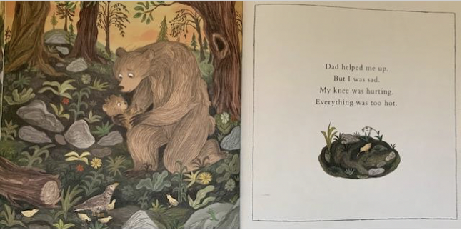  Look at page from book & cover and answer questions. | RE PowerPoint with Mrs Penfold
Tuesday | Oral blending: Watch Mrs Penfold’s video on Tapestry – introducing phoneme frames.  Independent task: Using phoneme frame template, adult to tap out the sounds for the pictures on the handout as modelled in video, child to blend and say the word. Show picture and check to see if they are right! | Oak National Academy ‘Pattern and Early Number’ – Lesson 1 Recognise, describe and copy colour and size patterns.  Independent task – Copy! Choose a pattern you found in your house – can you copy the pattern using colour bricks or colouring pencils? | Power of Reading:  Complete session two ‘‘Illustrate it’.  Describe the bears and draw.
Wednesday | Reading challenge:  Play Read and roll game, ‘reading ‘ay’ words.  Or you may like to do the jigsaw activity. Read, cut out, mix up and rebuild the words. | White Rose ‘Just like me’  Week 3 - Session 2  Independent: Continue!  Find objects from around your home as suggested in the video. A grown up could start the pattern for you to then copy or continue. | Power of Reading:  Complete session three ‘Talk about it’.  Have you ever had to be brave? | Zoom live 2:30 with Mrs Penfold!
Thursday | Watch the PowerPoint. Join in and write the words or make them with magnetic letters.  Play game ‘Forest Phonics’ on  https://www.ictgames.com/mobilePage/forestPhonics/index.html  1. Select ‘ay’ sound  2. Click on the snail and then the speaker button to hear the word.  3. Drag the letters from the bottom to make the word.  4. Click on ‘check’ and watch what happens!  (If you need help, click on the eye for a little clue)  You may like to write these words down. | White Rose ‘Just like me’  Week 3 - Session 5  Independent: Create!  Have fun creating your own patterns using bricks/toys around your home or natural objects outside. Can you create a simple repeating pattern?  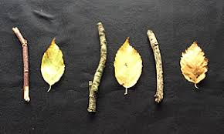    We will also upload a few more ideas to the website. | Power of Reading:  Complete session four ‘Imagine it’.  Write a note or draw a picture to cheer the bear up. | Story time ‘A Brave Bear’ on Tapestry
Friday | Please take this day to practice sounds, key words and reading.  We will upload Term 3 key words to the website. Please let us know if your child recognises these and we will email Term 4 to you directly. | Independent day – Create!  If you have paint, have a go at vegetable printing to make a repeating pattern. If not you could draw different vegetables to make a pattern or maybe you would like to use fruit on a skewer and make a fruit ‘pattern’ kebab! Try to 2 different colours or sizes in your repeating pattern. | Power of Reading:  Complete session five ‘‘Create it’.  Write or draw feelings in a ‘diary’. | Zoom live 2:30 with Miss Penighetti!

*Please note, all videos and PowerPoints will be uploaded to the website by 9am on the day. We will upload any worksheets on Sunday evening so if you wish you can print in advance. They will also be uploaded on the day for easy access.

