What do you know about superheroes?
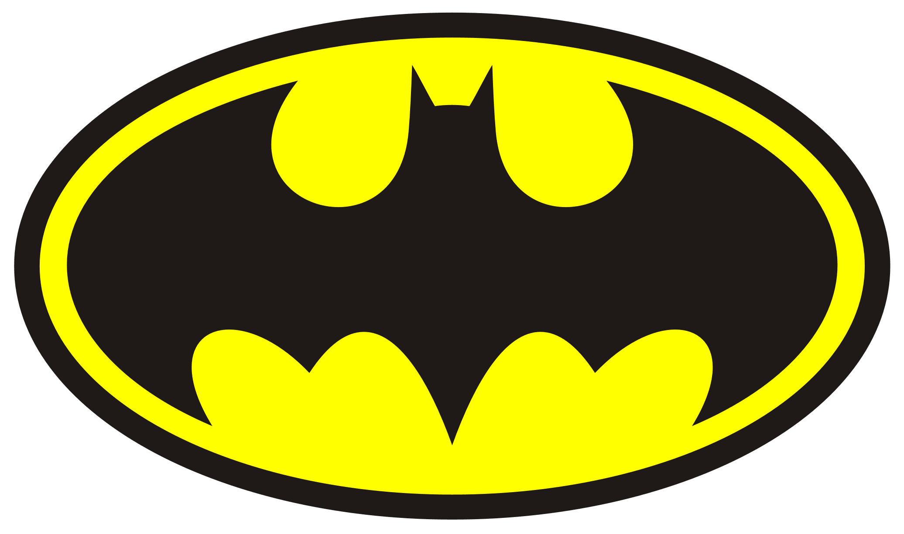
This Photo by Unknown Author is licensed under CC BY-SA

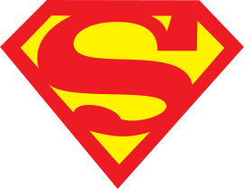

- Can you name any superheroes?
- How would you describe a superhero?
- Have you got a favourite superhero? Why?
- Would you like to be a superhero?
- What would you like to find out about superheroes?
- You may like to find some pictures of superheroes, cut them out and create a poster.
- You could dress up as your favourite superhero.
- Draw a picture of your favourite superhero and label it.
- If you have any superhero toys you could set them up and play with them.

