Willow Class Home Learning Term 2

Week | Activity
Week 1 | This week I would like you practice practice practice your times tables. You can write them out in your book, practice recalling them with a family member or even use some maths books. Try to focus on the ones you are not as confident to improve! | Due in by 5th November
Week 2 | Anti bullying week is from the 13th to the 17th of November this year. We will be doing lots in school to recognise the effects bullying has and how as a collective we can stomp it out for good. The theme this year is ‘Power for Good. Become a Member of ABA – Let’s Unite Against Bullying! Can you design a poster aimed at KS1 to explain how spreading the word to be kind has an impact on everyone. |   Due in by12th November
Week 3 | Even if you're a long way from the beach, the ocean is always with you. The water you drink and the air you breathe come to you from the sea. The water on Earth is constantly moving and being recycled in a process called the water cycle. How can you represent the water cycle? It can be a drawing a model or an explanation text. Make sure you are labelling each part and explaining how they contribute. | Due in by 19th November
Week 4 | This term we have been looking at oceans and how they have changed over time. We know it is important to protect. our oceans  What problems do our oceans face from the use of plastics and what can we do to protect them? Can you write a persuasive letter to other children explaining why it is so important to protect our oceans. |   Due in by 26thNovember
Week 5 | From the evidence you have found out using Matthew chapters 1 and 2, can you draw a picture to show how Jesus could have been the Messiah? Make sure you are annotating your drawing to explain your thinking. | Due in by 3rd December
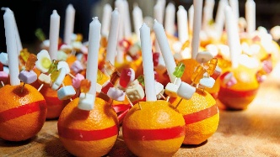  Week 6 | Its nearly Christmas!! In school we are lucky to enjoy a Christingle service all together. Can you draw a Christingle and label the meaning of the different parts?  If you were to make your own Christingle would you use different objects to symbolise the different meanings? Draw another showing what you would use and why. | Due in by 10th Dec ember

