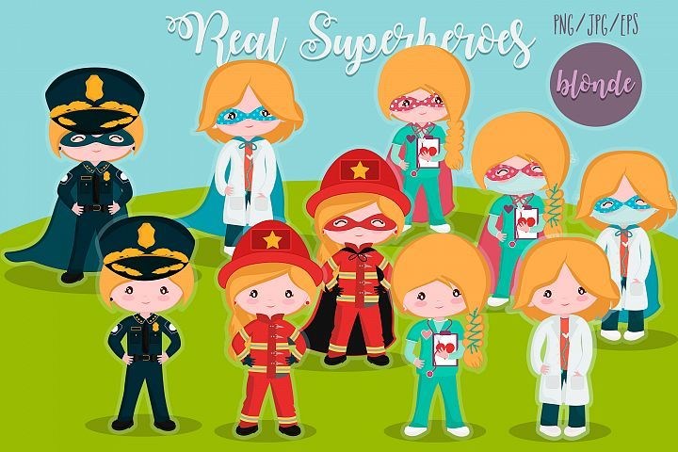
Home Learning tasks: Week beginning 1st March.

Superheroes!


We hope the children have enjoyed the first question linked to our new topic. Again, on Friday we will upload another focus question with some practical activities.

Mathletics – Tasks will be added at the beginning of the week for you to do in your own time.

Bug club: We hope you are enjoying reading some of the books. We will keep an eye on your ‘book library’ but please do let us know if you have no books left. You must complete the quizzes to finish each book.

We will share our learner of the week again in our Friday zoom session

Email: chestnutteacher@west-malling.kent.sch.uk

Power of Reading
We continue with our Power of Reading sessions and this week our story focus is ‘Ruby’s Worry. These sessions combine our topic, communication & Language and reading skills. We would normally do this session at 1pm in school. You may like to fit this in at the same time on your timetable. We will upload the document which includes pictures and key questions on a Monday. On the planning grid below, we have outlined which section to complete each day. You do not need the book to complete the activities.

Phonics –
We continue with sound Set 2 of Read Write Inc. If you feel your child needs to revisit some of the sounds in speed set 1 there are scheduled Read, Write Inc programs running daily at 9:30am. Search Read, Write, Inc Daily Phonics lessons. The sounds that will be aired this week are: -
1st March – ‘d’
2nd March – ‘t’
3rd March – ‘i’
4th March – ‘n’
5th March – ‘p’

Maths – Pattern
This week we will be exploring more complex patterns.
1. Continue a repeating pattern (e.g. red, blue, blue, red, blue, blue)
2. Create their own pattern. (colour/size/shapes/objects)
If you wish to use the videos, please use White Rose on Monday and Tuesday - ‘Building 9 and 10’ - week 3
https://whiterosemaths.com/homelearning/early-years/week-3/
and Oak National Academy – Pattern and early Number on Thursday session 3.
https://classroom.thenational.academy/units/pattern-and-early-number-187a

 | 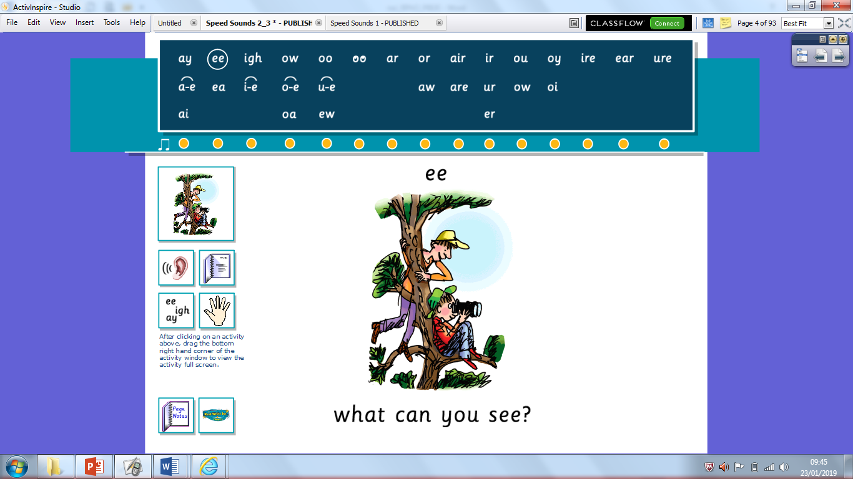  Reading/Phonics:  ee  What can you see? | 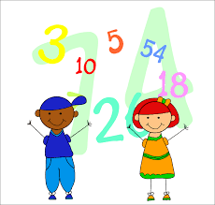  Mathematics  Pattern | Communication & Language/Power of Reading: | Story time!
Monday | Please watch RWI video introducing new sound ‘ee’.  https://www.youtube.com/watch?v=2ayayozjF_k  Independent activity – Write the sounds ‘nk, ng, sh, ch, qu, th, ay, ee’ on separate pieces of paper. Hide them around the house. Ask your child to go on a treasure hunt to find them. Once they have found one, they must bring it back and say the sound to you. To challenge them you could ask them to think of a word with that sound in. | White Rose  Building 9 and 10 week 3: Lesson 4  Independent task –  Find things around the house or cut out shapes/pictures. Ask your adult to start a repeating pattern, can you complete it? How would you describe the pattern?  Fork, fork, spoon, fork, fork, spoon.  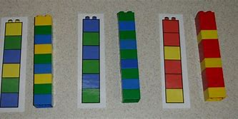  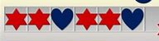  Extra: Play Topmarks- shape patterns  https://www.topmarks.co.uk/Search.aspx?q=repeating%20patterns | Power of Reading:  Complete session one ‘Explore it’.  Look at the picture from the book and answer questions. | RE PowerPoint with Mrs Penfold
Tuesday | Oral blending: Watch the PowerPoint.  Independent – Play snakes and ladders ‘ee’ game.  Roll a dice and move along the board game. Say the word, then the sounds and say the word again. | White Rose  Building 9 and 10 week 3: Lesson 5  Independent task –  Make up your own movement pattern with someone in your house. Can you complete their pattern? Can they complete your pattern? Can you describe the patten?  Jump, jump, turn, jump, jump, turn, jump, jump, turn | Power of Reading:  Complete session two ‘‘Illustrate it’.  Draw things that make you happy.
Wednesday | Reading challenge:  Play the matching pairs game. Cut out the words and pictures. Turn them over. Take it in turns to pick a word card and picture card. Read the word card, do they match? If yes keep them if not return them.  If you can’t print you may like to write some ‘ee’ words on pieces of paper (double) and play a matching game.  See, keep, beep, week, feet, deep, sleep, feed, bee, meet, weed, cheek, sheep, teeth, queen, jeep, seed | Independent day:  Continue to explore movement patterns. Can you make up another repeated movement pattern?  Could you use some musical instruments or your body to make up a musical pattern?  Adults you may like to make up a repeated pattern but make a mistake each time. Can your child spot the mistake and explain it? | Power of Reading:  Complete session three ‘Talk about it’.  Look at the front cover and answer the questions. | Zoom live 2:30 with Mrs Penfold!
Thursday | Writing/word building: Watch the video uploaded to Tapestry.  Look at the I spy sheet. Can you spot all the things with the sound ‘ee’ in them? Write them down or build the word with your letters.  Or you could go on your own ‘ee’ hunt, record what you find. | Oak academy  Pattern and Early number: Lesson 3  Independent task:  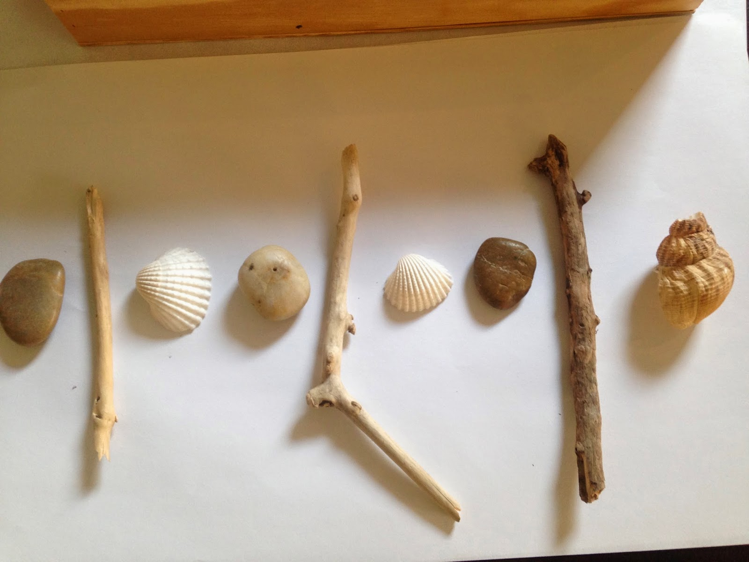    Collect natural objects from outside and create your own pattern. See how creative you can be! Don’t forget to take a photo. | Power of Reading:  Complete session four ‘Imagine it’.  How could you help Ruby? | Story time ‘Ruby’s worry’ on Tapestry
Friday | Please take this day to practice sounds, key words and reading. | Independent day –  *Create your own patterned T-shirt or socks.  You may wish to use the template attached to the webpage or draw your own outline.  *If you have beads or buttons make a bracelet or necklace with a repeating pattern.  *Make your own wrapping paper- use paints, stickers, ink stamps, drawing, cut out shapes/pictures | Power of Reading:  Complete session five ‘‘Create it’.  Write a note or draw a picture for Ruby to take her mind off her worry. | Zoom live 2:30 with Miss Penighetti!

*Please note, all videos and PowerPoints will be uploaded to the website by 9am on the day. We will upload any worksheets on Sunday evening so if you wish you can print in advance. They will also be uploaded on the day for easy access.

