How might a superhero protect us?
What super powers would you like?

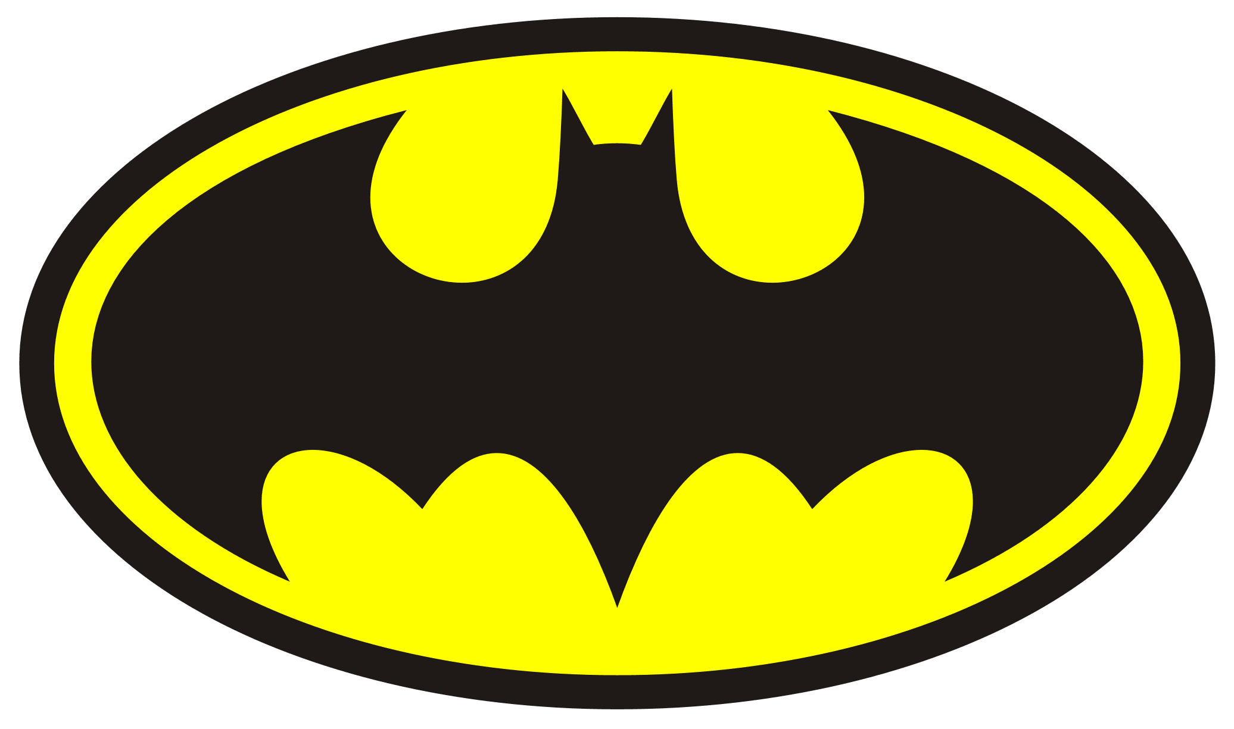
This Photo by Unknown Author is licensed under CC BY-SA

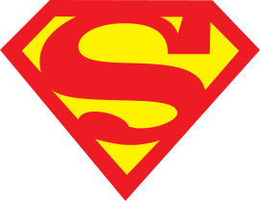

- Act out scenarios of rescuing people/animals. If you have any superhero toys you may like to use these.
- Find out what superpowers your favourite superheroes have. For example super strength, flying, super speed
- What does a superhero need to be like? For example, brave, honest, kind………
- Make your own superhero cape (use a bin liner)
- Make a superhero mask.
- Can you name any special gadgets superheroes have? Make some of your own gadgets using junk modelling.
- Draw/paint yourself as a superhero, ask an adult to help you label your picture. Think about your special powers. What would your name be?
- Use a ball of wool as laser beams and set it up across the room. Hide a teddy and pretend it has been captured by a villain. You need to rescue it.
- If you have any superhero comics, ask an adult to read you the stories.
- Build your own superhero headquarters!



