
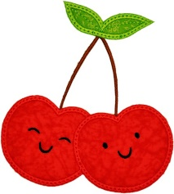
Cherry Class Home Learning
Term 3

Maths  - Practise the times tables we have learnt, the 2, 5 and 10 times tables. Start by skip counting eg. 2 4 6 8 10 12.  If you are already confident, challenge yourself to learn the 3s and 4s too. It will help to practise writing them out.  - Have a go at cutting fruit into halves and quarters. Make sure they are in equal parts! Then have a go at halving and quartering amounts. For example 4 grapes shared by 2. Can you write the related division sentence?  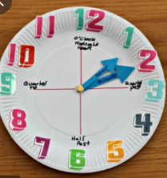  - Have a look at a digital and analogue clock. Practice telling the time to o’clock and half past.  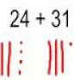  - Keep pactising adding 2 digit numbers. Either by drawing tens and ones, or using the column method. | English  - Keep learning the Year 2 words.  You can find a full list of Yr 1 and 2 tricky words in the class page.  Write a sentence using each of these.  every great break pretty beautiful after class grass pass fast last past father mother brother sister  - Can you name 5 nouns, adjectives and verbs?  - Draw an imaginative picture.  Label it and write sentences to explain what is happening.  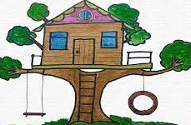
  Noun-  place, person, thing | Adjective- describing word | Verb- action word
  eg. dog | eg, red | eg. run
Geography- India  - Think of a way to help you remember the 7 continents and 5 oceans of the world.    - Use an online map to find India.  Which continent is it in?  What is the capital city? | 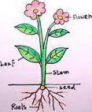  Science- Plants  - Do you have a favourite plant?  Look up 5 common plant species in the UK.  - Draw a picture of a plant and label the key parts: root, stem, leaf and flower.
Choose 1 or 2 things to do each week to help support learning in class. Some may take longer than others and some may need to be practised more often.
Bring your homework books in on Monday 7th February to share your work and receive castle points.

