Oak Class Spellings Week beginning 6/9/2021
words | Monday | Tuesday | Wednesday | Thursday | Friday | 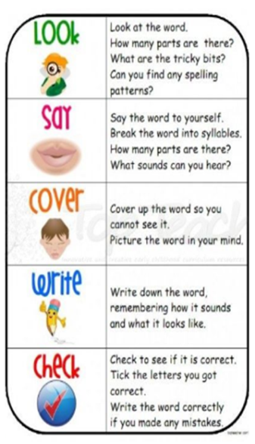
actual
believe
busy
certain
decide

