Oak Class Spellings Week beginning 27/9/2021
words | Monday | Tuesday | Wednesday | Thursday | Friday | 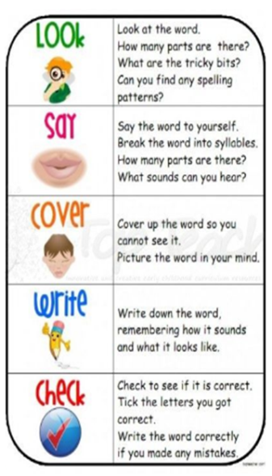
arrive
circle
complete
early
famous

