Oak Class Spellings Week beginning 4/10/2021
words | Monday | Tuesday | Wednesday | Thursday | Friday | 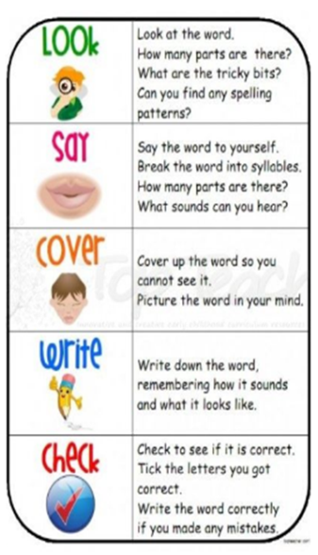
across
because
clothes
different
every

