Work for Home Week beginning 22/11/21

Mathetics – only tasks assigned please!
Maths workbook – available on BugClub. P 56-62 Negative numbers and revision of rounding to 10/100/1000
Negative number games: https://mathsframe.co.uk/en/resources/resource/37/placing_numbers_on_a_number_line
(please select -10 - -10 to begin!)

https://www.mangahigh.com/en-gb/games/minusminers

https://www.topmarks.co.uk/Flash.aspx?f=Temperaturev2

This week’s spellings:
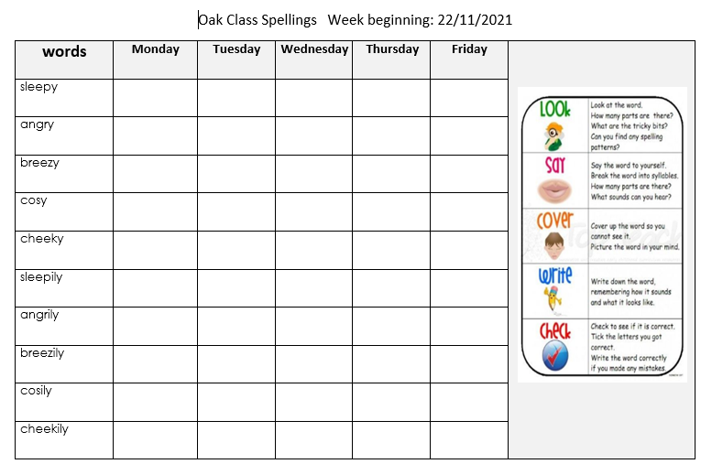

History Research
What can you find out about Ancient Greek clothing, or food or family life.
Create a page ( or 2 or 3!) full of facts you find, interesting things and pictures you have drawn.
https://www.bbc.co.uk/bitesize/topics/z87tn39

