Oak Class Spellings Week beginning 6/12/2021
words | Monday | Tuesday | Wednesday | Thursday | Friday | 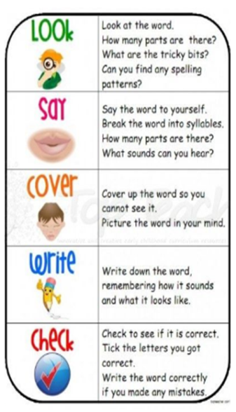
eight
pray
vein
disobey
weigh

