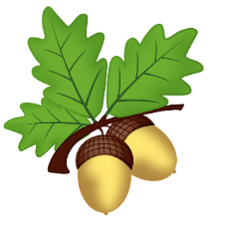
Oak Class Homework
Term 3
Priority homework:
Every week please read at least 5 times for at least 15 minutes at a time. This is the most important homework you can do. Reading regularly will improve your comprehension, spelling, grammar, creativity and general knowledge. You will also have spellings to learn and Mathletics to challenge yourself with! Don’t forget your multiplication tables too.
Title | Task | Return on
Get Moving! | January is often a time for new resolutions and promises to ourselves. Your homework this week is to do one physical activity a day for at least 5 minutes (so you are out of breath!) This should be extra activity and not exercise you normally do. Try some high intensity moves. You can find videos on YouTube like this one:  https://www.youtube.com/watch?v=L_A_HjHZxfI  Record what you do and when you do it in a table in your book. At the end of your week of exercise do you feel any different? | 17th January
Orion | At the moment, Orion is very easy to spot in a clear sky. Have a look one evening to see if you can spot Orion and draw the star constellation in your book. Find out why this constellation has this name. If you would like to, research another star constellation too. | 24th January
RSPB Big Garden Birdwatch | This weekend the ‘Big Garden Birdwatch’ run by the RSPB takes place. Spend some time outside (or at a window) watching the birds. Record what you see. You could paint, draw, collage or sketch your favourite bird that you spot. You could also create a fact file about a bird you see. If you would like to, you can register on their website and record what birds you spot.  https://www.rspb.org.uk/ | 31st January
Phases of the Moon | The moon’s appearance slowly changes shape each evening from being a new moon to a full moon. Draw what the moon looks like on different days of the week – see if you can notice how it changes.  Can you investigate why this happens? | 7th February



