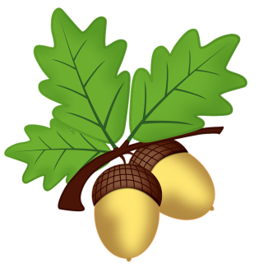
West Malling C. E. Primary School
Oak Class
Curriculum Newsletter: Term Three 2021-22

Dear Parents and Carers,

We hope you have enjoyed the festive period and we wish you a happy new year!
Welcome back, please see below the learning for this term.

If you have any questions, please do not hesitate to speak to Mrs Hillsdon or Mrs Sands or email us on
oakteacher@west-malling.kent.sch.uk

English  Reading  Please continue to encourage daily independent reading for enjoyment at home. It is also important that you listen to your child regularly, ensuring that they are reading exactly the text on the page and also checking their understanding. For example, their understanding of vocabulary and punctuation, making predictions and comparing the text to other books they have previously read.  In class, we are continuing with whole class guided reading sessions 4 times a week. We explore a variety of different texts, checking the children’s understanding verbally and in more formal written questions.  Spelling  The children will continue to get weekly spellings in Oak class. These will be taken from the suggested words from the Year 4 curriculum and from our school spelling scheme.  The spellings will be sent home on Monday and we will test the children the following Monday – this means they have the weekend to learn them which may help some of you with busy schedules!  Punctuation and grammar lessons will be taught discretely in a separate lesson each week.  This term we will be learning about the use of colons before a list, main and subordinate clauses and using inverted commas (or speech marks).  Our Power of Reading text this term is ‘Charlotte’s Web’. The class are already really enjoying it and we have been impressed with how they have responded to it so far.  It is important that we explore the text together as a class, so please do not read it at home or be tempted to watch the film. We will be writing diary entries, some persuasive writing and a narrative. | Mathematics  This term we will be practising and improving our addition and subtraction skills using up to 4 digit numbers. This will involve using columns and exchanging and regrouping.  We will then move onto perimeter of shape towards the end of the term.  If we are successful we may even sneak a little division and multiplication in too!  We will be focusing on the 6/7/8x tables this term in class. Please support your child with their learning of these at home too, thank you! | Science  This term in science we will be investigating sound. Some of the learning we will be covering: undertaking scientific enquiries, identifying how sound is made, exploring how vibrations travel and recording findings.
Computing
We will use computers to help with research this term.
Music
We will have a particular focus on music next term with lessons from our wonderful specialist music teach Mrs Cripps.
Latin
We continue finding out about our Latin family and the vocabulary associated with daily life.
 | Topic-  Our topic this term is Amazing Agriculture!  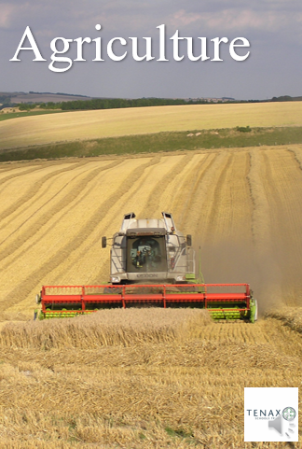  We will be learning about different types of farming and how farming has changed our landscape over many years.  We will use our research skills and also learn the meaning of new geographical vocabulary. We will look at maps and compare physical and human features in the landscape. | P.E.  Mrs Hillsdon: Monday Swimming  Mrs Sands: Friday – outdoor PE  This term we will be learning football skills, attacking and defending as well as applying these skills in mini-games.
RE
This term we will be learning about incarnation and the Trinity. We will be exploring the Gospels and thinking about what these texts may mean to some Christians. The children will think about how Christians show their beliefs about God.

PSHE
This term the children will be exploring the unit ‘Being Me in My World’. The class will be thinking about the importance of being inclusive, basic democracy, how to try to be empathetic and how to work as a team,
Homework
Expectations of homework include:
Reading –As part of the RALF initiative, children should read EVERY day. Please sign the sheet in the back of their homework books to show they have done so.
Maths – Mathletics practise will form the only maths homework, however multiplication tables practise is vital! Please also record any maths work your child does on the sheet in the back of their homework books.
Spellings – As mentioned above, children will have some spellings that have been sent home which will then be tested in school each week.
Other homework – This will be set at the beginning of each term. Although this is not compulsory, we advise that the children engage in this home learning as much as possible as we try to set fun and interesting activities that will develop them as learners and will use many of the skills we teach in class. There will be a different activity for each week and castle points will be awarded generously!
Spellings (Monday) and homework (termly) will be sent home via a paper copy but there will also be an online version you can find on our Oak Class webpage.

Multiplication Tables
By the end of this academic year the children are expected to know their tables up to 12 x 12 with a 5 second recall. We will practise at school, but we ask that you also take as much time as you can to go through them at home. There are lots of websites where the children can play games but nothing beats chanting them to get them to stick in their heads! We will put links to some multiplication games on Oak page on the school website.
The order in which we learn the X tables is: 2x, 5x, 10x then 3x, 4x, 8x then 6x, 7x, 9x, 11x, 12x.

Reading
We have spoken to the class about the importance of always having a reading book and reading for enjoyment. This book could be from home or from school but it needs to arrive in school each day and go home with your child at the end of the day. We are lucky to have a well stocked book corner with good quality texts. In previous years, we have allowed children to take these books home as long as they log them out (and back in again) in our class book. Please can you support your child in respecting and taking care of these books. If a book gets lost or badly damaged, we will ask for a voluntary contribution for a replacement book.

Useful Reminders
Snacks
We have noticed some rather unhealthy snacks creeping onto the playground recently! Please remember that a playtime snack is a piece of fruit or vegetable. Please help us with this by not sending crisps, cereal bars or “fruit snacks” such as winders or yoyos.

P.E. - Mrs Hillsdon – Mondays (swimming)
Mrs Sands – Friday (outdoor – football)
Please ensure that stud earrings are removed on P.E. days and that long hair is tied back. We cannot be responsible for jewellery that is worn to school. If your child comes into school with earrings on a PE day and cannot remove them, unfortunately they will not be able to participate in PE lessons according to our PE policy. Thank you.

Mrs Hillsdon Mrs Sands Mrs Fuller

