Oak Class Spellings Week beginning 24/1/2022
words | Monday | Tuesday | Wednesday | Thursday | Friday | 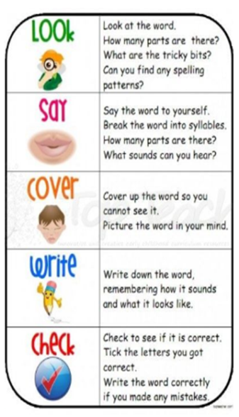
explosion
division
television
decision
confusion

