Oak Class Spellings Week beginning 7/2/2022
words | Monday | Tuesday | Wednesday | Thursday | Friday | 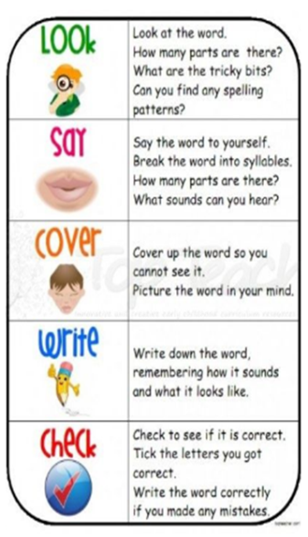
unique
antique
grotesque
cheque
picturesque

