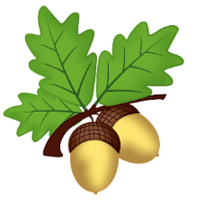
Oak Class Homework
Term 4
Priority homework:
Every week please read at least 5 times for at least 15 minutes at a time. This is the most important homework you can do. Reading regularly will improve your comprehension, spelling, grammar, creativity and general knowledge. You will also have spellings to learn and Mathletics to challenge yourself with! Don’t forget your multiplication tables too.
Title | Task | Due
  Spring is coming! | Write a short poem or prayer looking forward to the arrival of Spring. Make sure your presentation, punctuation and spelling are brilliant too! Can you decorate or illustrate it? | Monday 28t^{h} February
Catkins and Pussy Willow | What are catkins and pussy willow? Can you find out 5 facts about them?  See if you can find any while you are out and about. |   Monday  7th  March
  Daffodils | There are many different species of daffodil. Can you spot any differences between them?  Create a table comparing similarities and differences between 2 different daffodil species. | Monday 14th  March
Easter Eggs |   Lots of people give and receive Easter Eggs around this time of the year.  Imagine you are like Willy Wonka and you can invent your very own Easter Egg. What would be in it? What would the packaging be like?  Draw your egg and label all the yummy parts and design the box too! | Monday 21st  March
Easter | Easter is a very important time for Christians. Find out about 3 different aspects of the Easter celebrations and then create either an A4 poster or a booklet (from 1 piece of A4 paper) to show what you have found out. | Monday 28th  March



