Oak Class Spellings Week beginning 21/2/2022
words | Monday | Tuesday | Wednesday | Thursday | Friday | 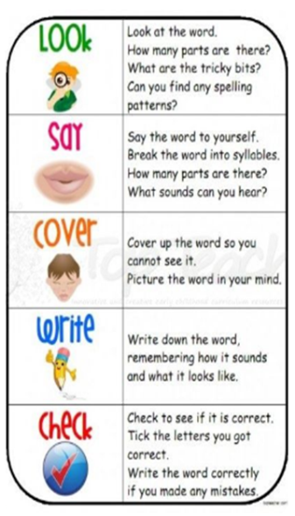
subway
submarine
subtitle
subheading
submerge

