Oak Class Spellings Week beginning 14/3/2022
words | Monday | Tuesday | Wednesday | Thursday | Friday | 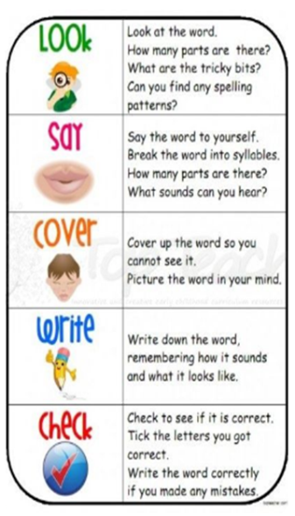
unknown
incomplete
treasure
angrily
curious

